

**中原大學 雲端計算平台實務**

**12/10-作業報告**

**Microsoft Azure AI Fundamentals Explore natural language processing**

**資訊四乙 10727211 林彥輝**

**授課教師：鍾武君 教授**

**中華民國一一○年十二月**

# Learning Path Intro

**Microsoft Azure AI Fundamentals Explore natural language processing**

**https://docs.microsoft.com/en-us/learn/paths/explore-natural-language-processing/**

# Summary Homework Assignment

## Model 1: Analyze text with the Language service

1. Create a Cognitive Services resource

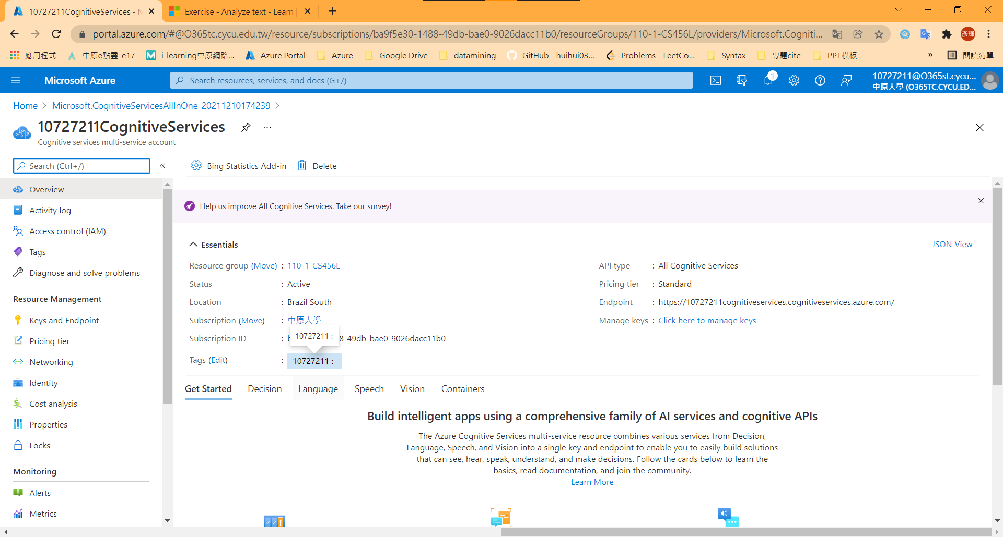

Part1: 英文版網頁教程

1-2. config client application

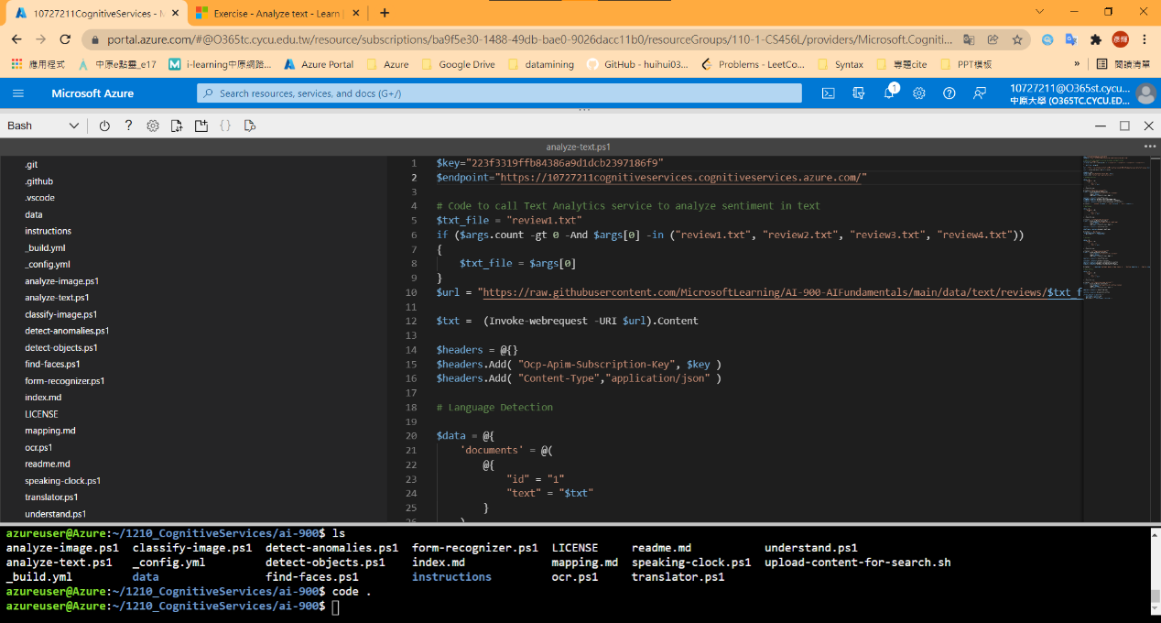

1-3. Run code and get results

review1.txt

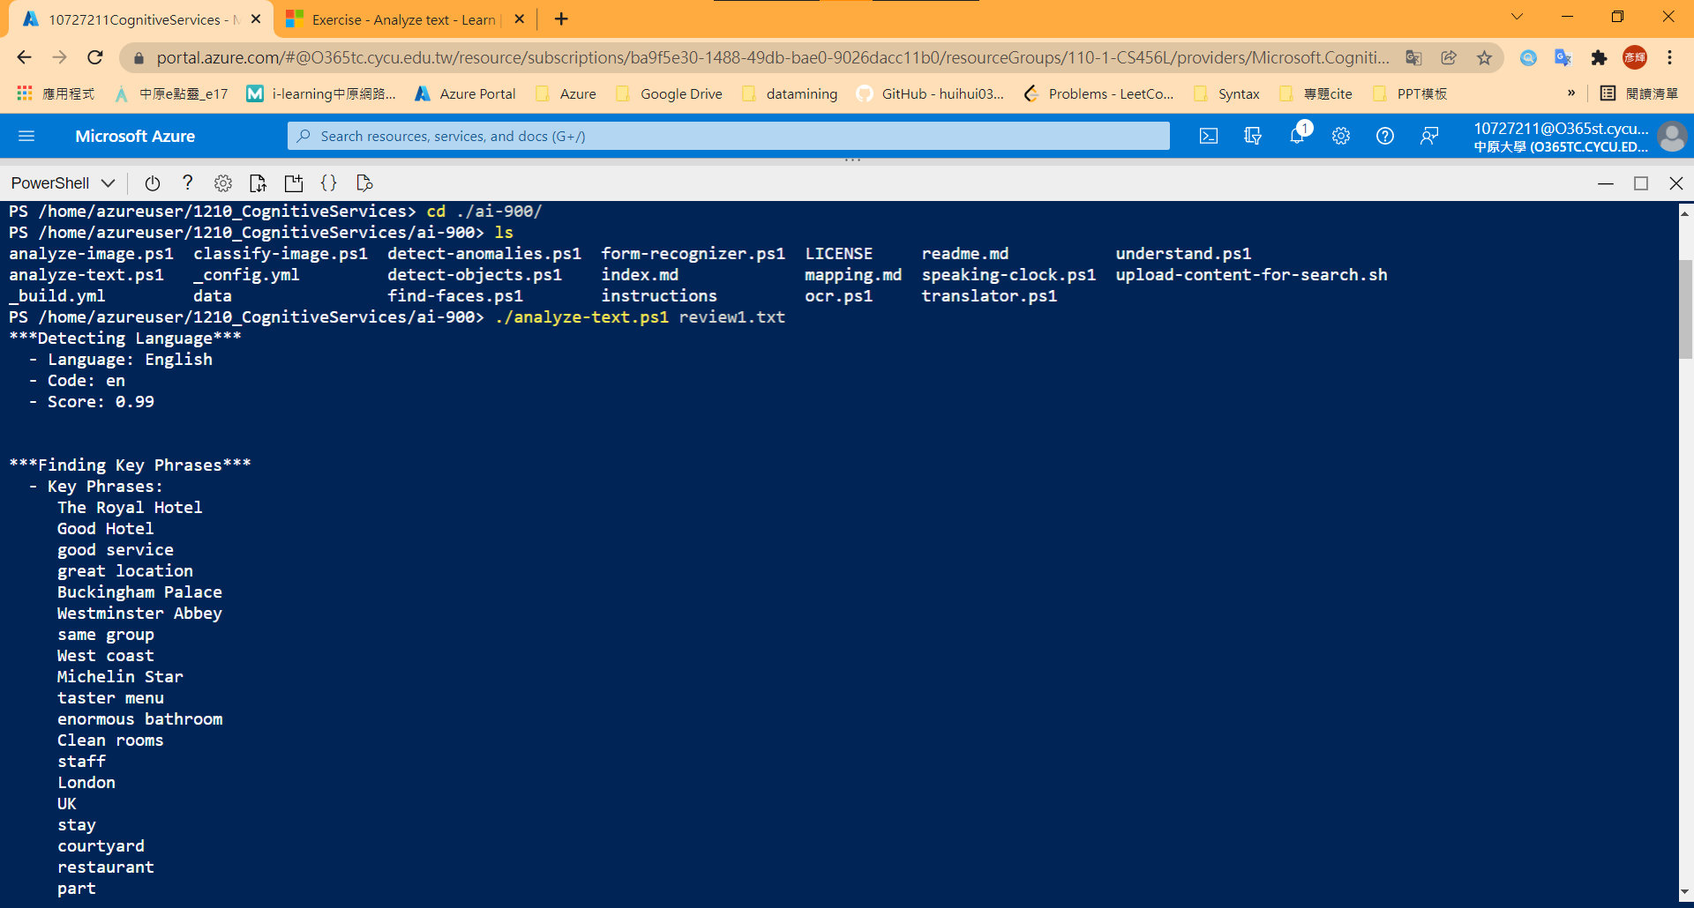

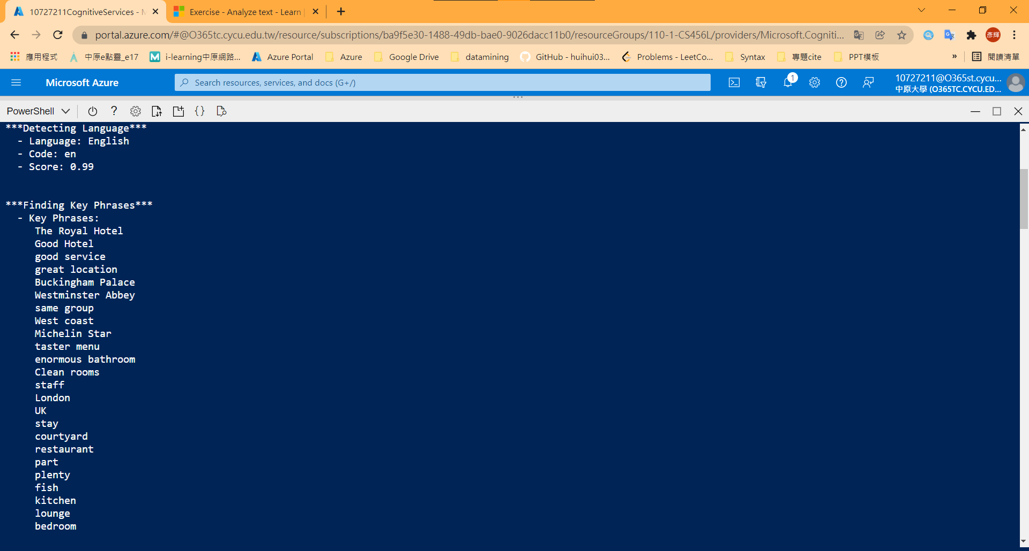

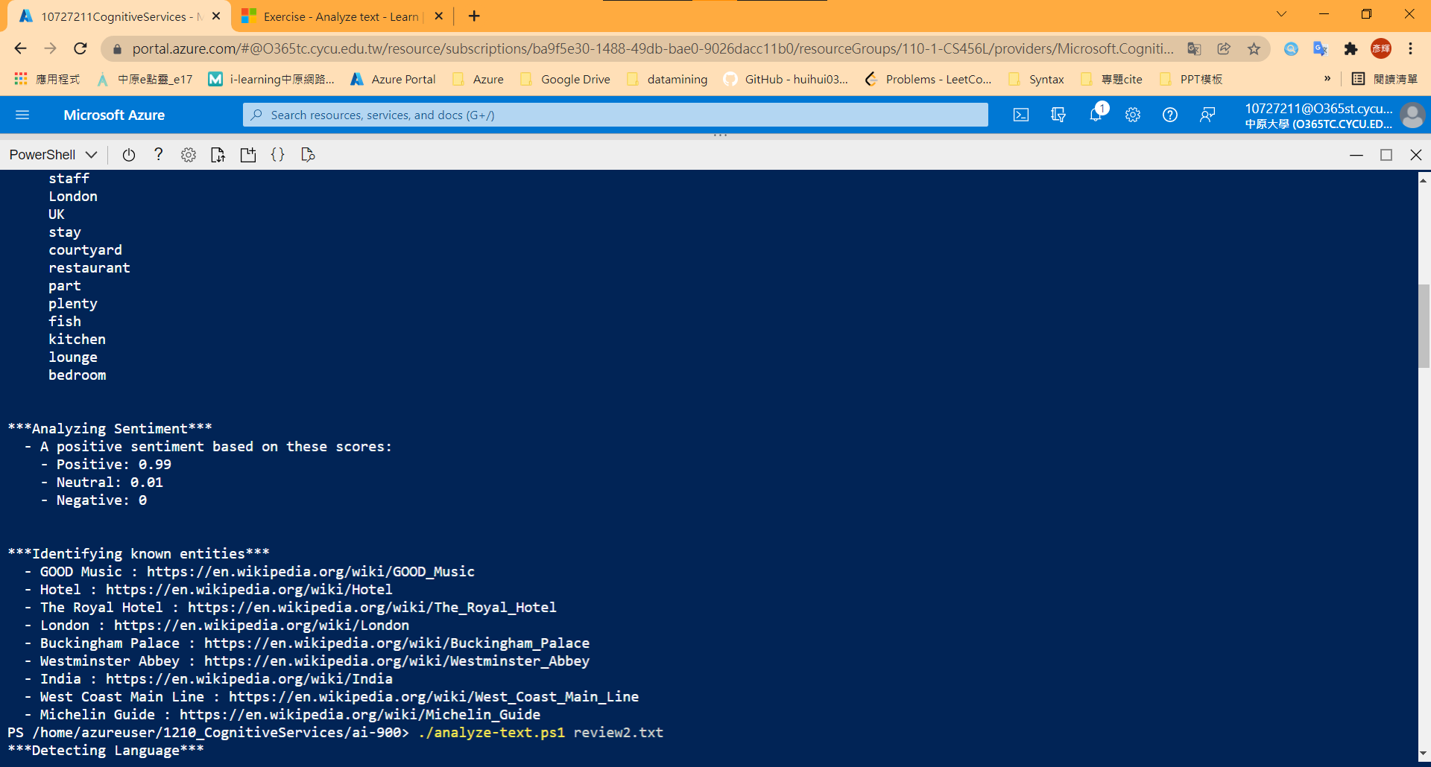



review2.txt

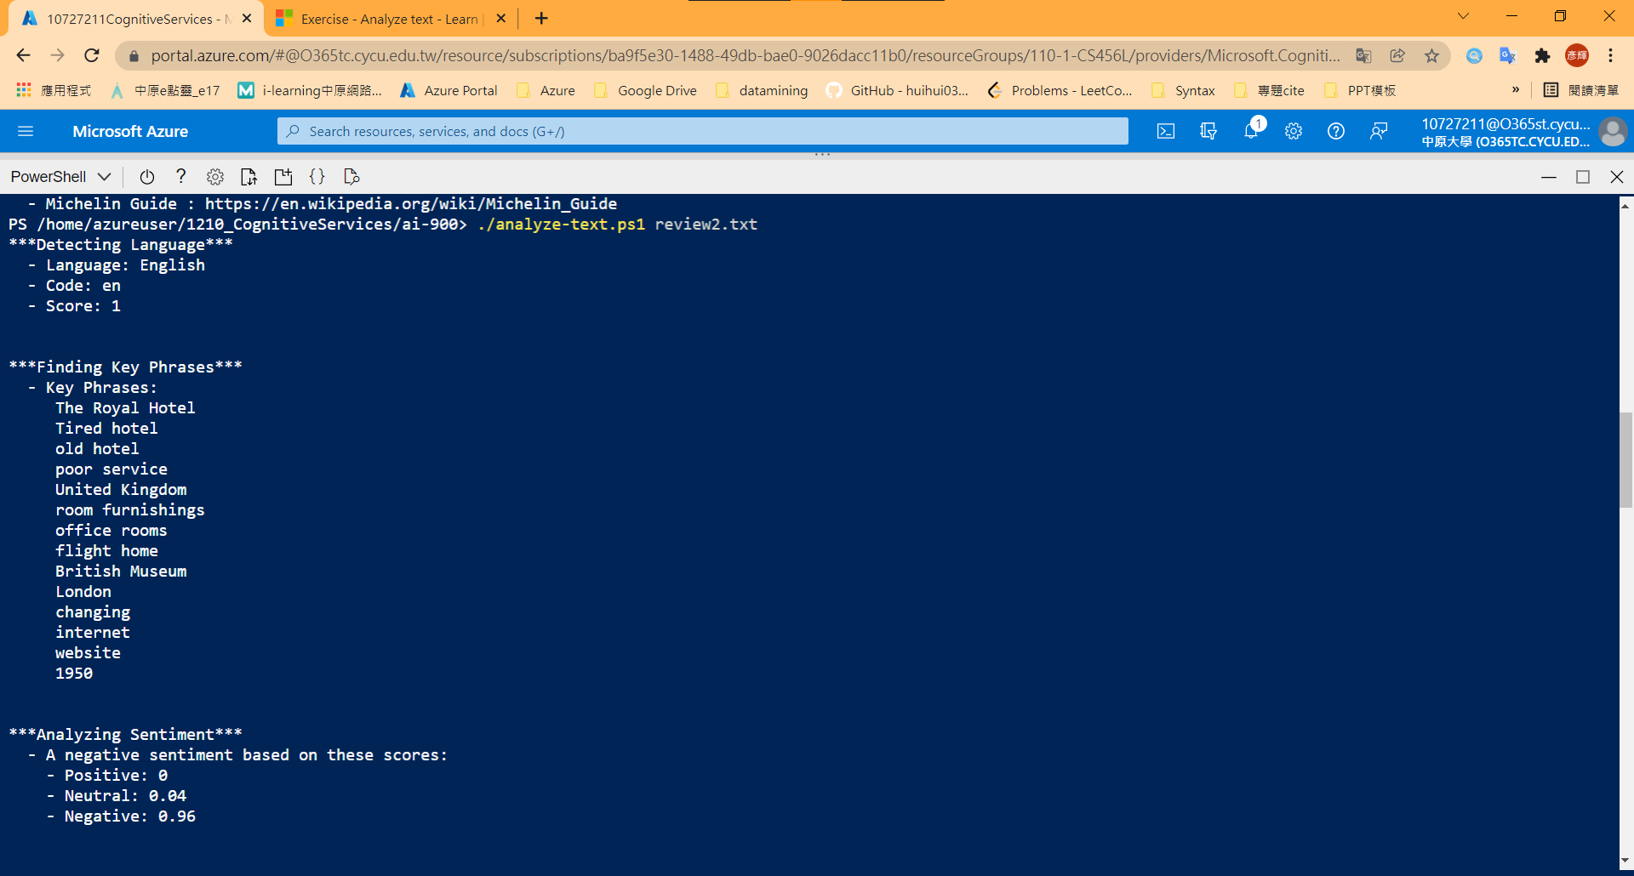



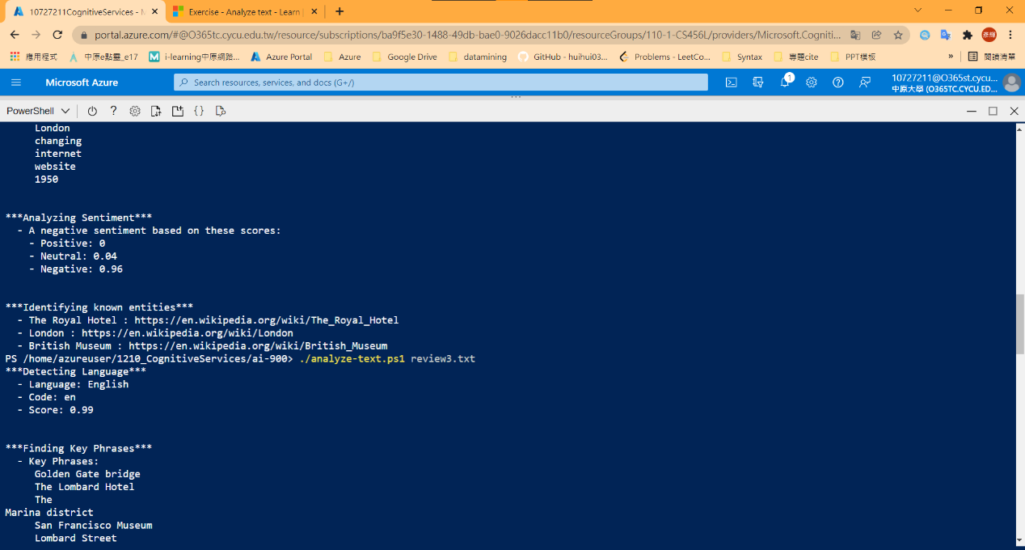

review3.txt

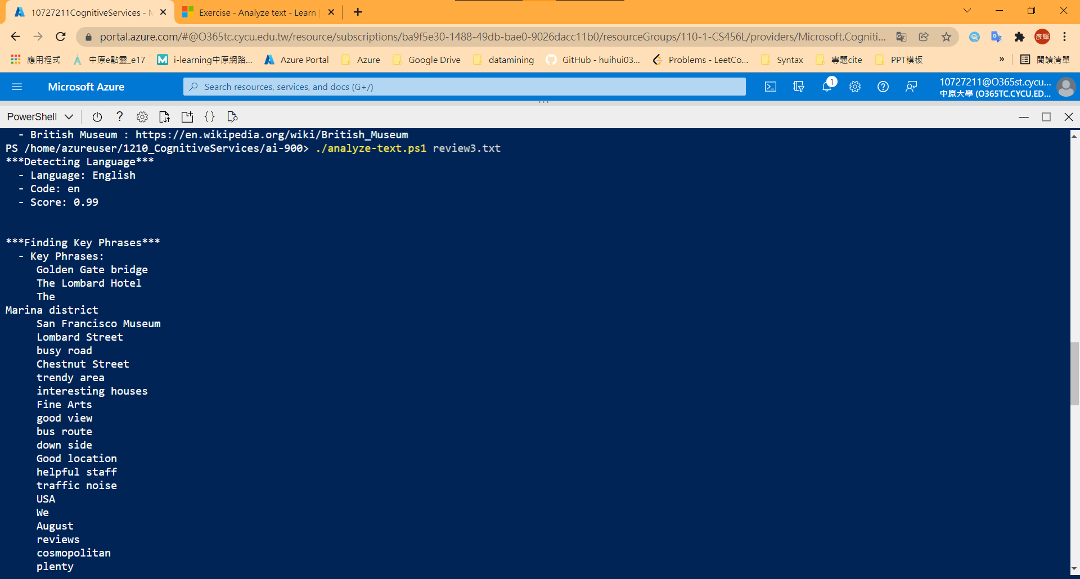

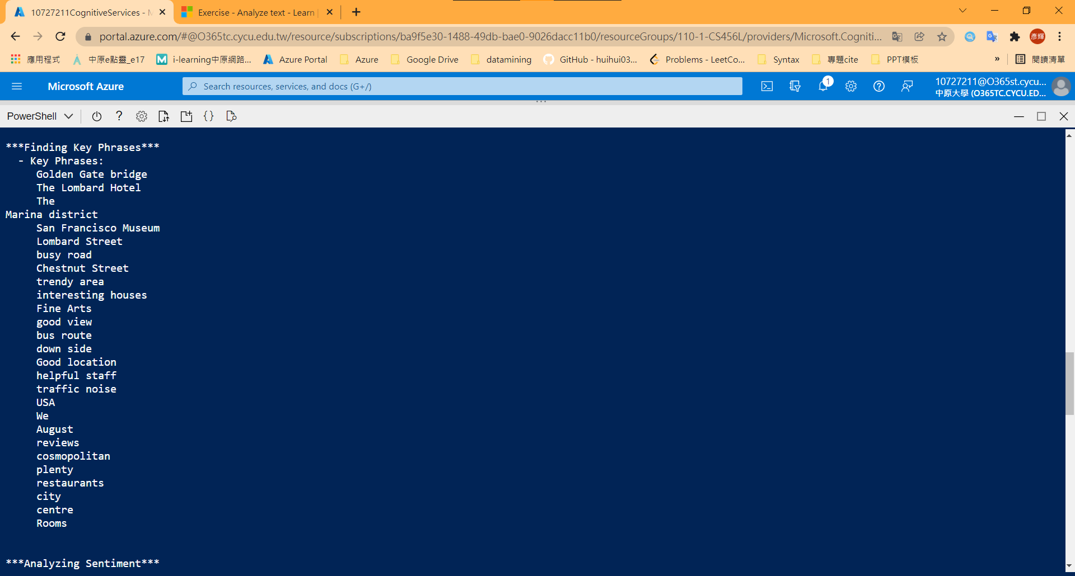

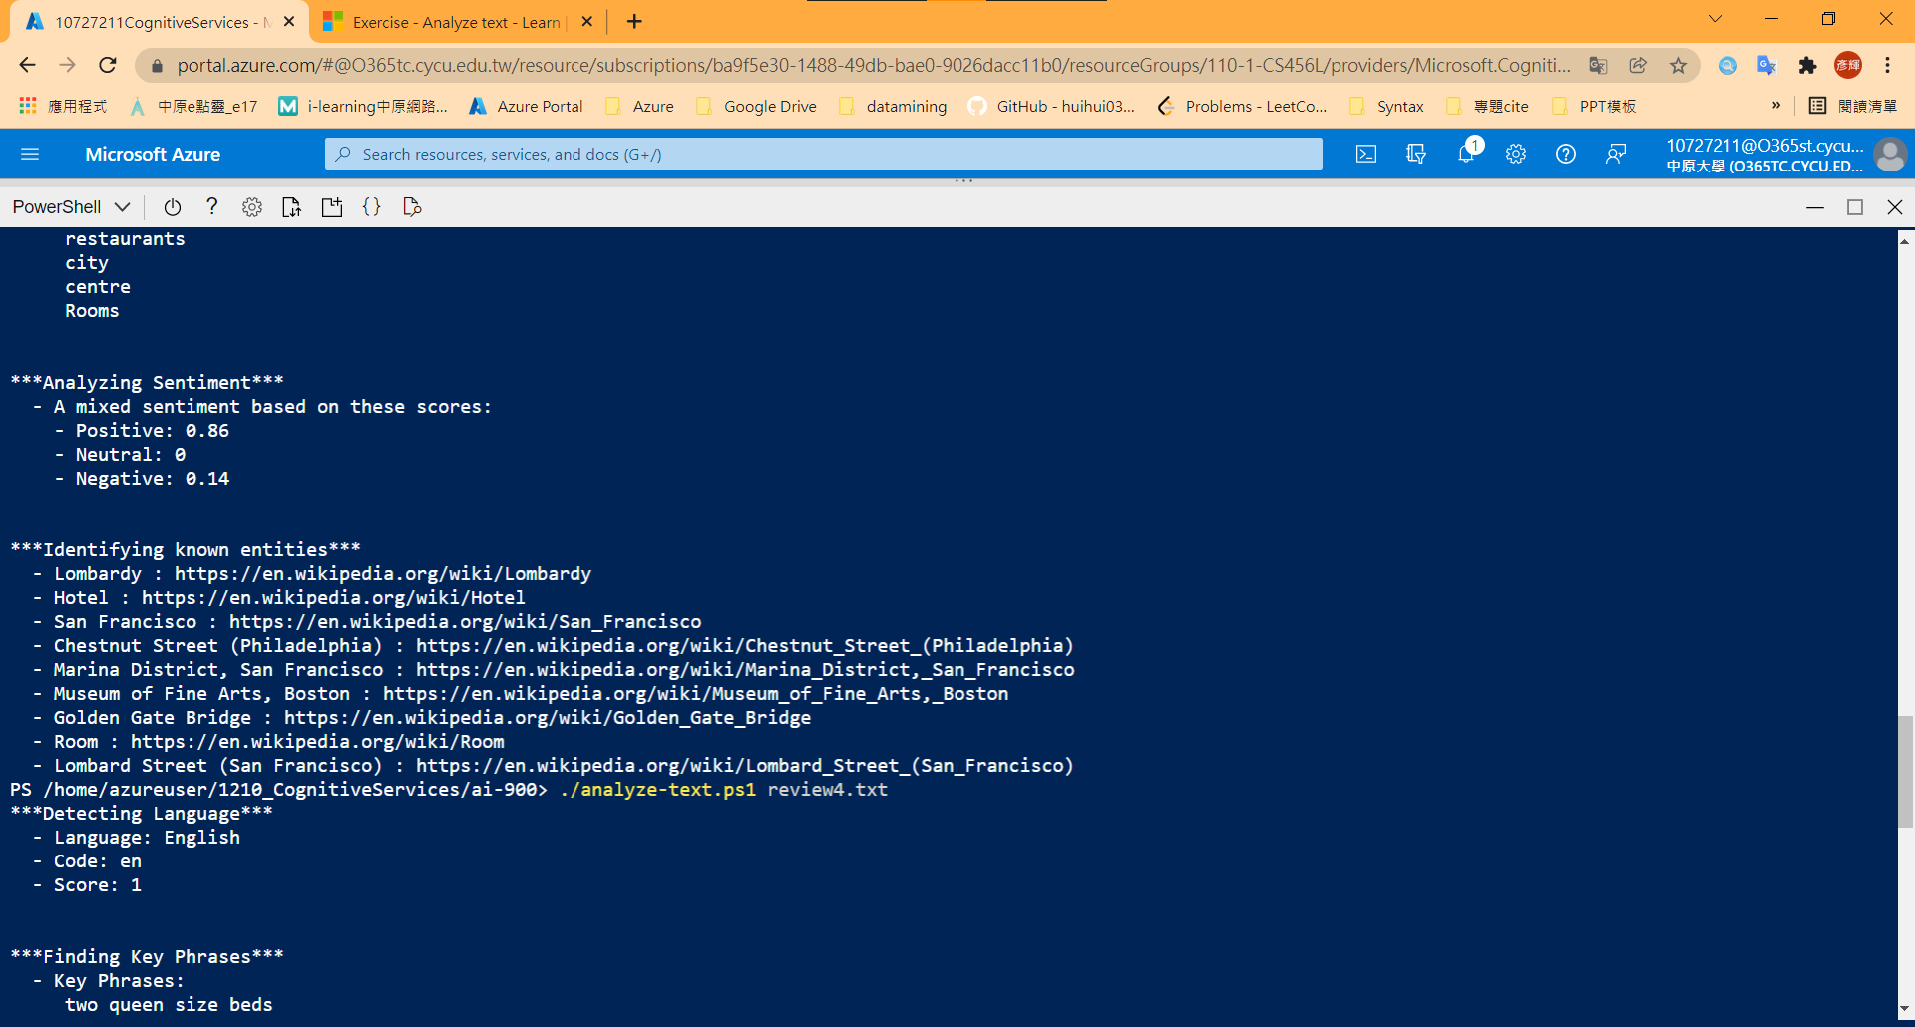

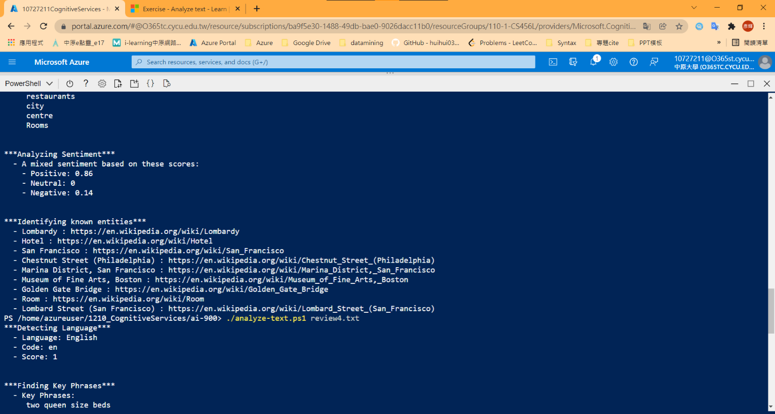

review4.txt

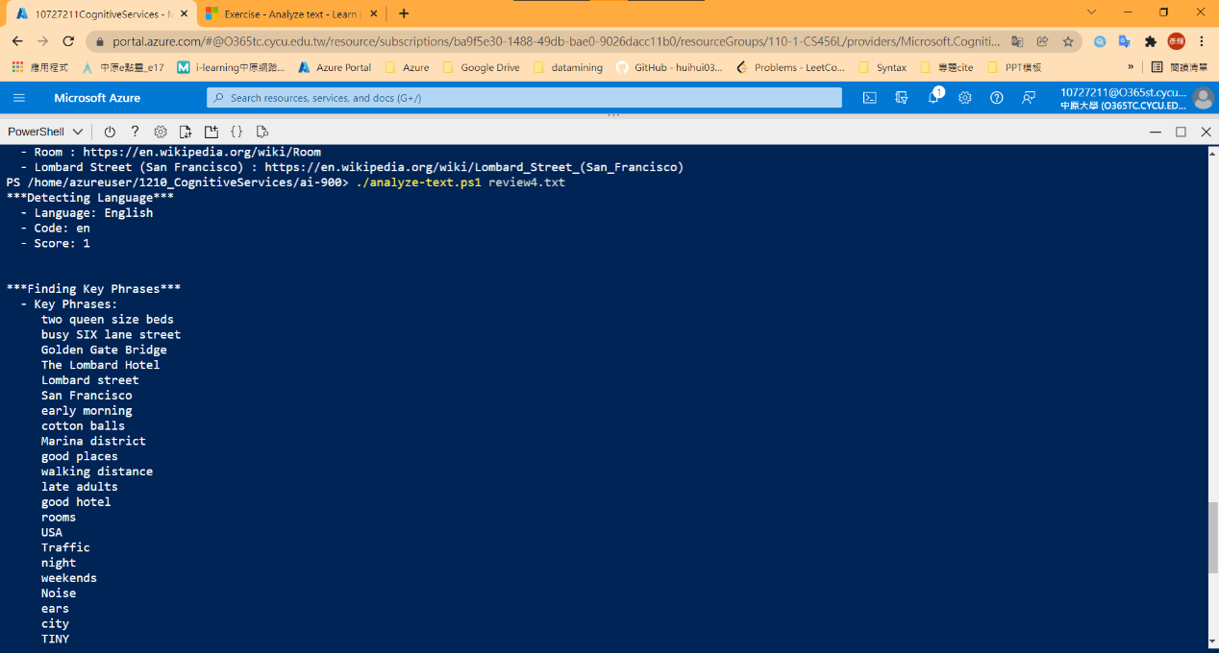

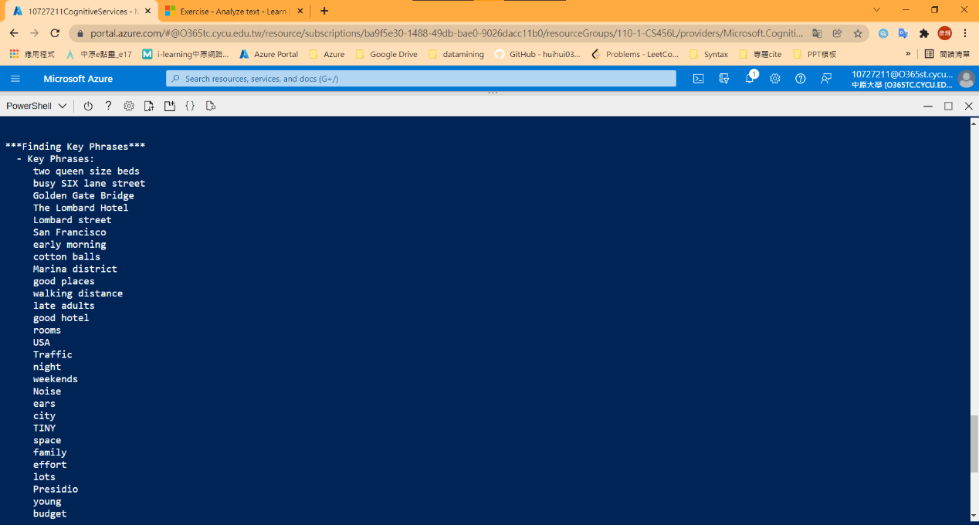

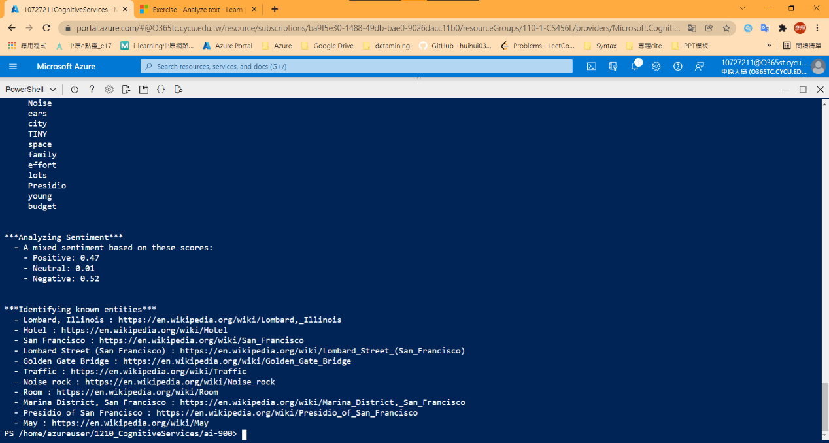

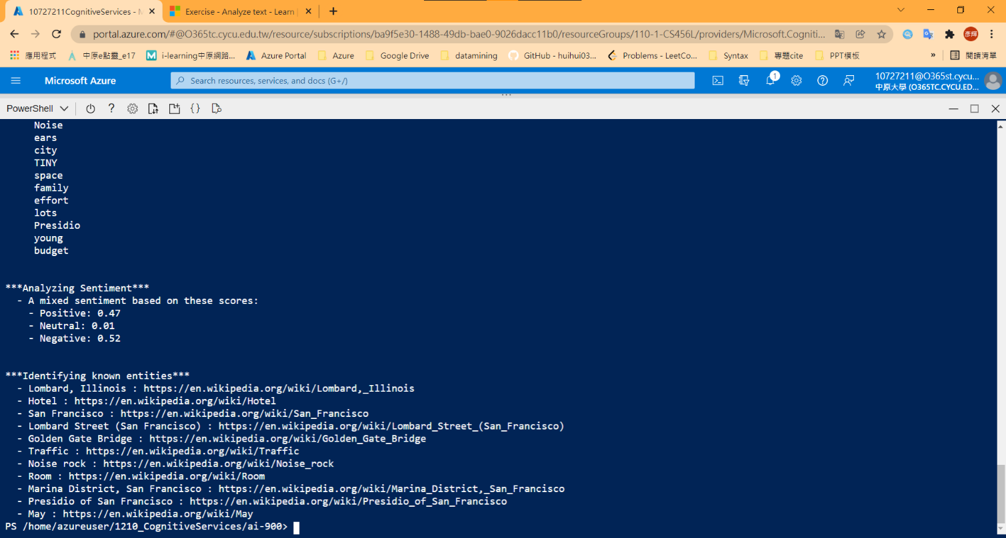

Part2: 中文網頁教程

2-2 View Review Documents

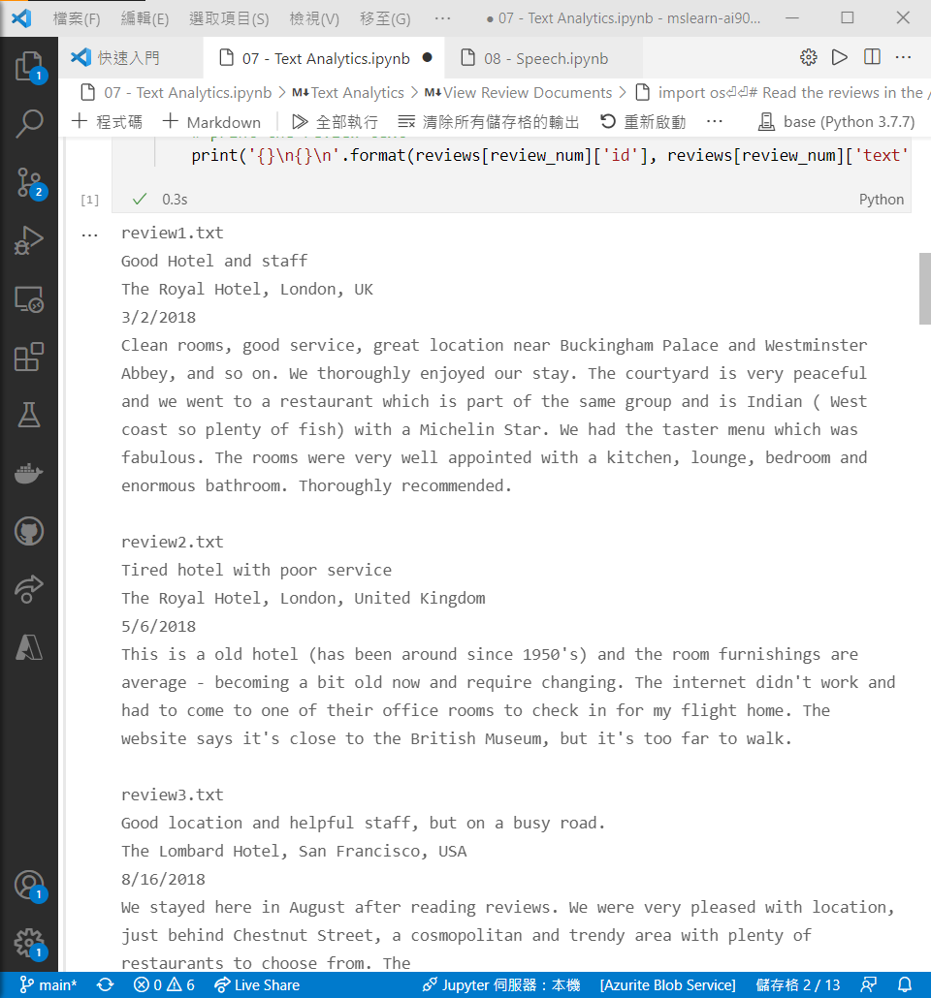 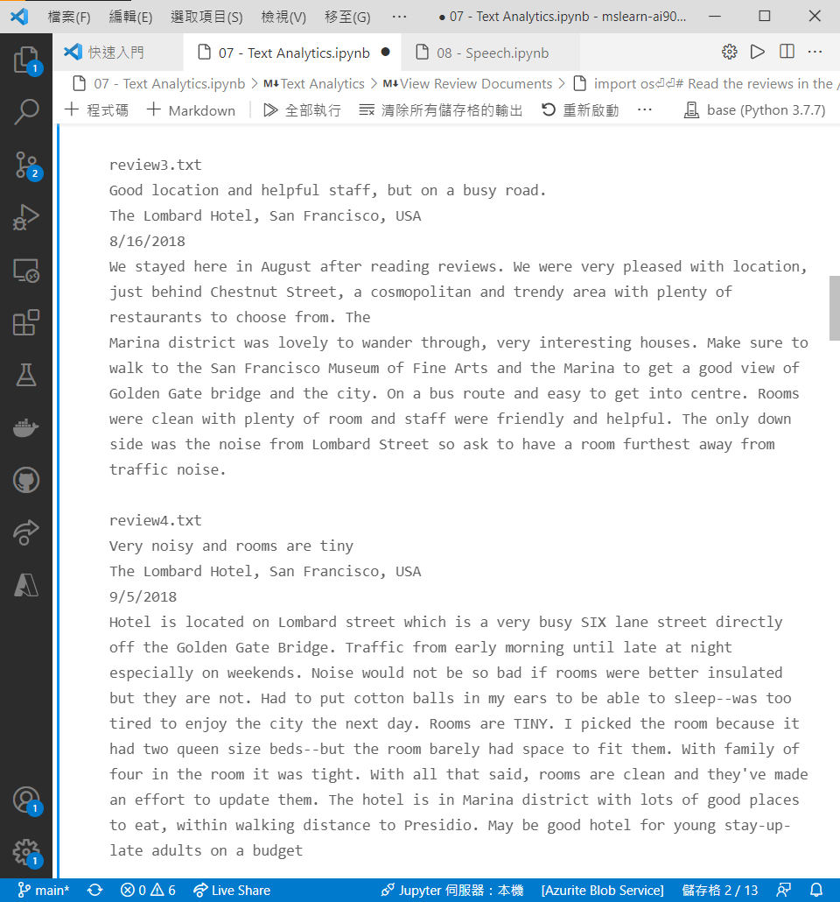



2-3 Get the Key and Endpoint for Cognitive Services resource

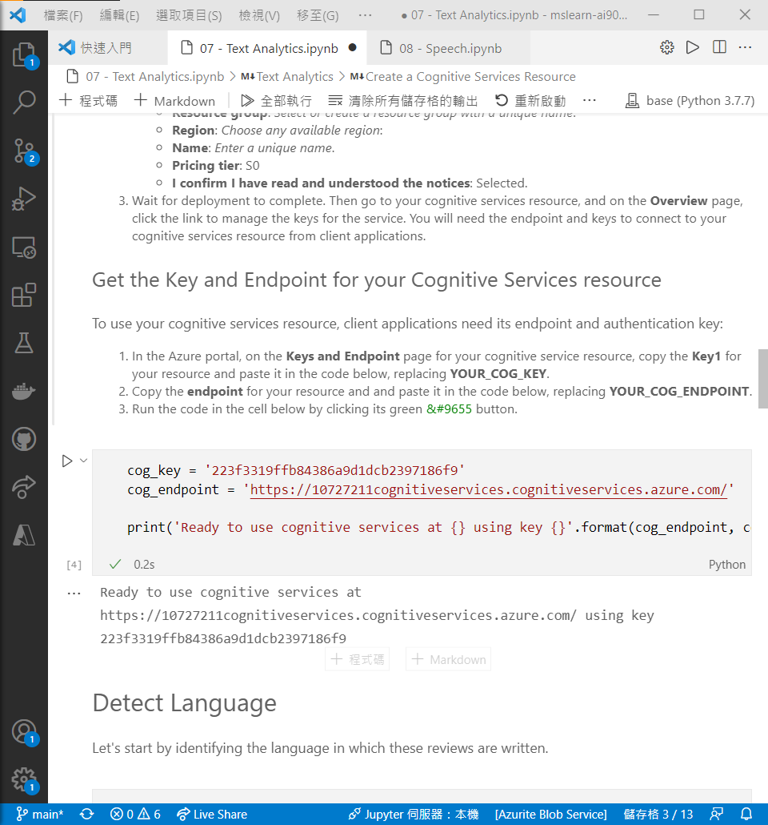

2-4 Detect Language

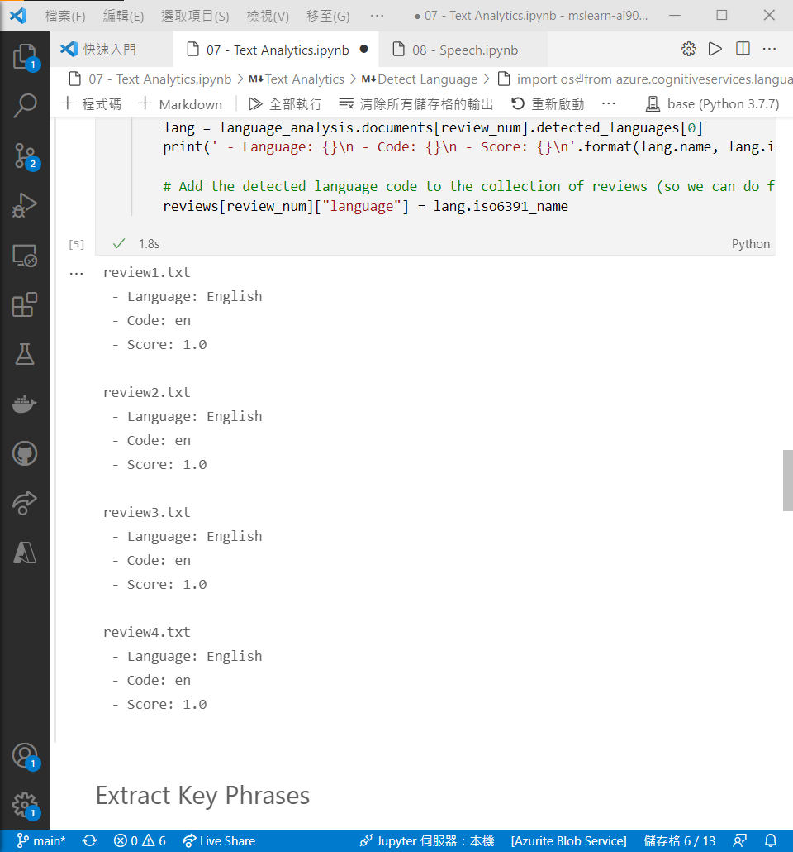

2-5 Extract Key Phrases

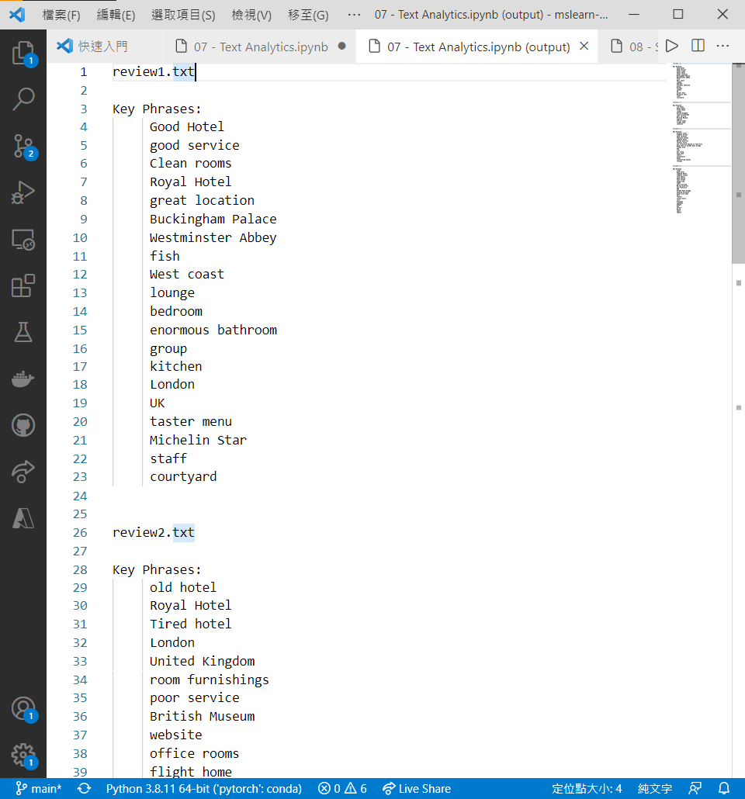

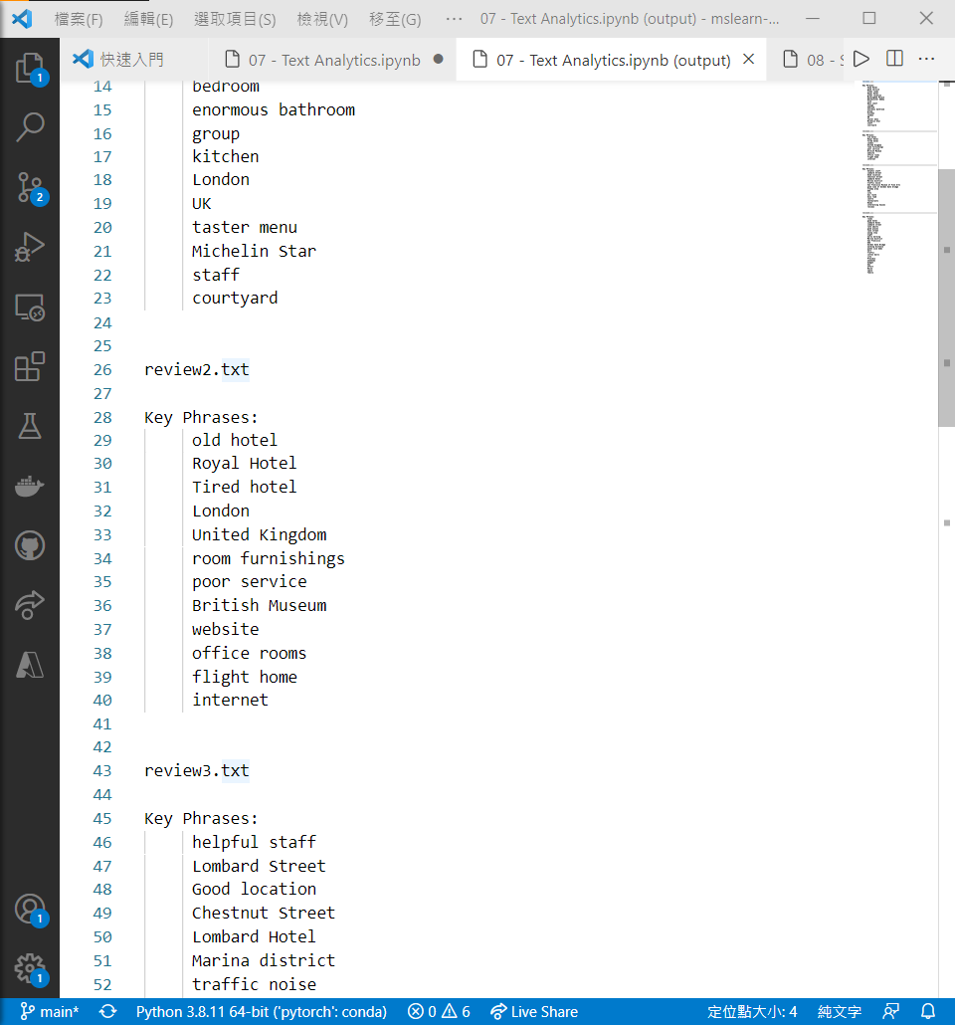

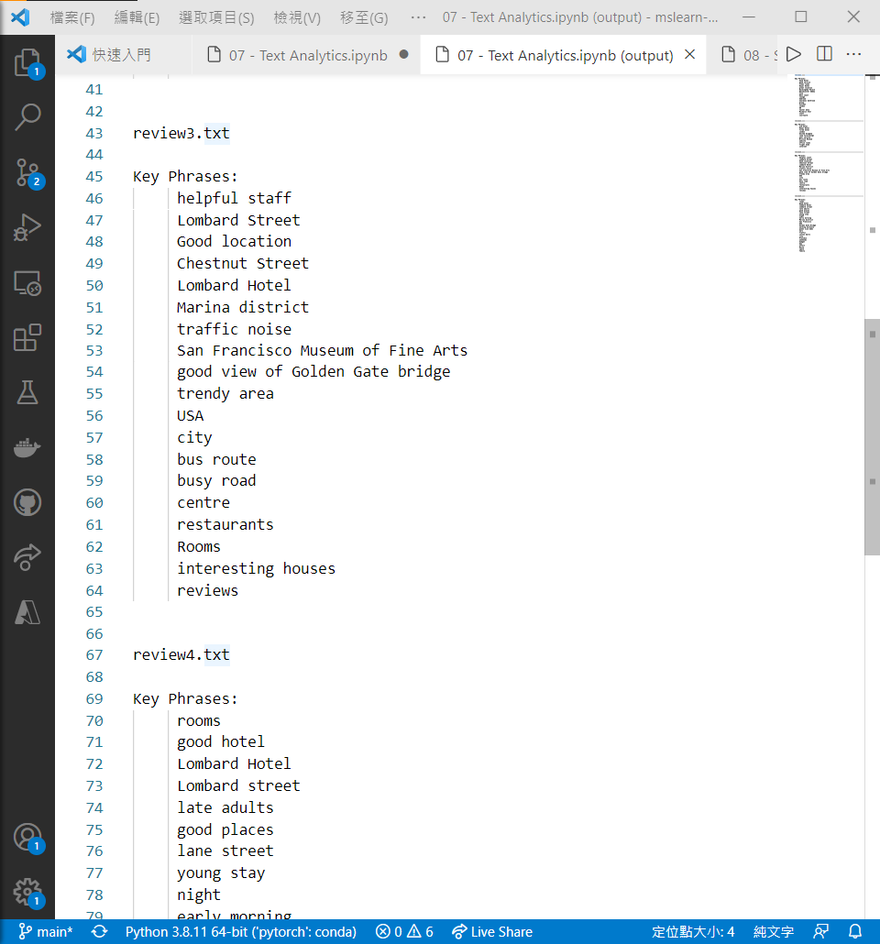

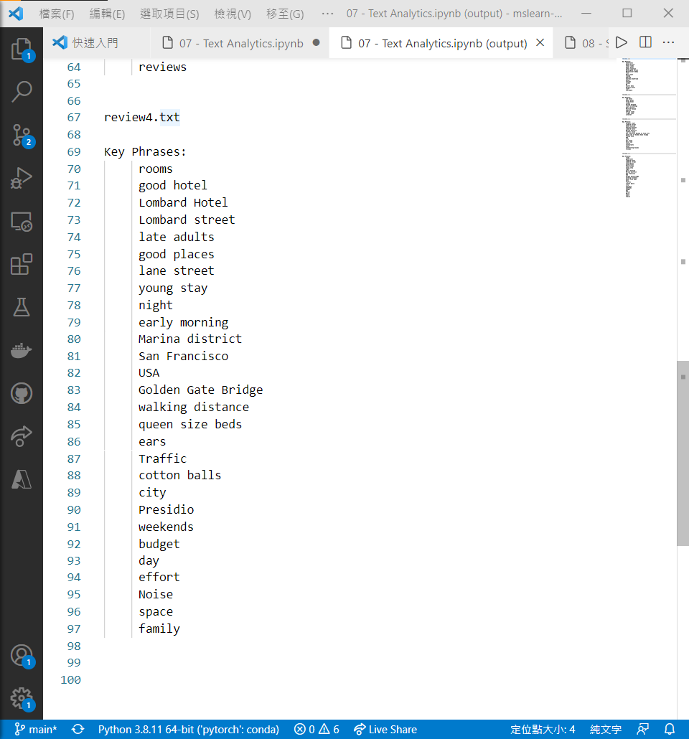

2-6 Determine Sentiment

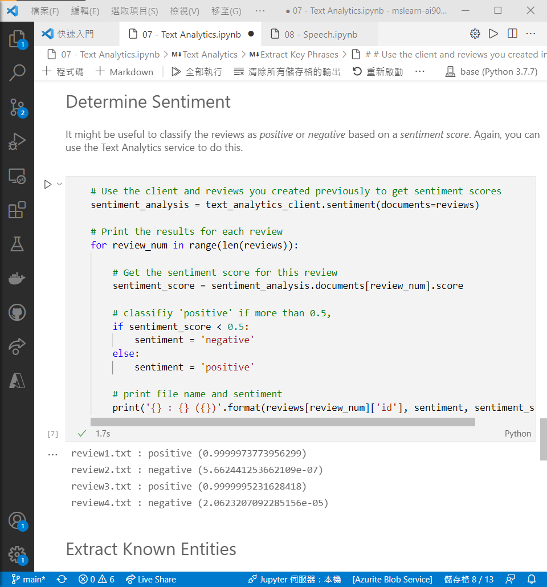

2-7 Exract Known Entities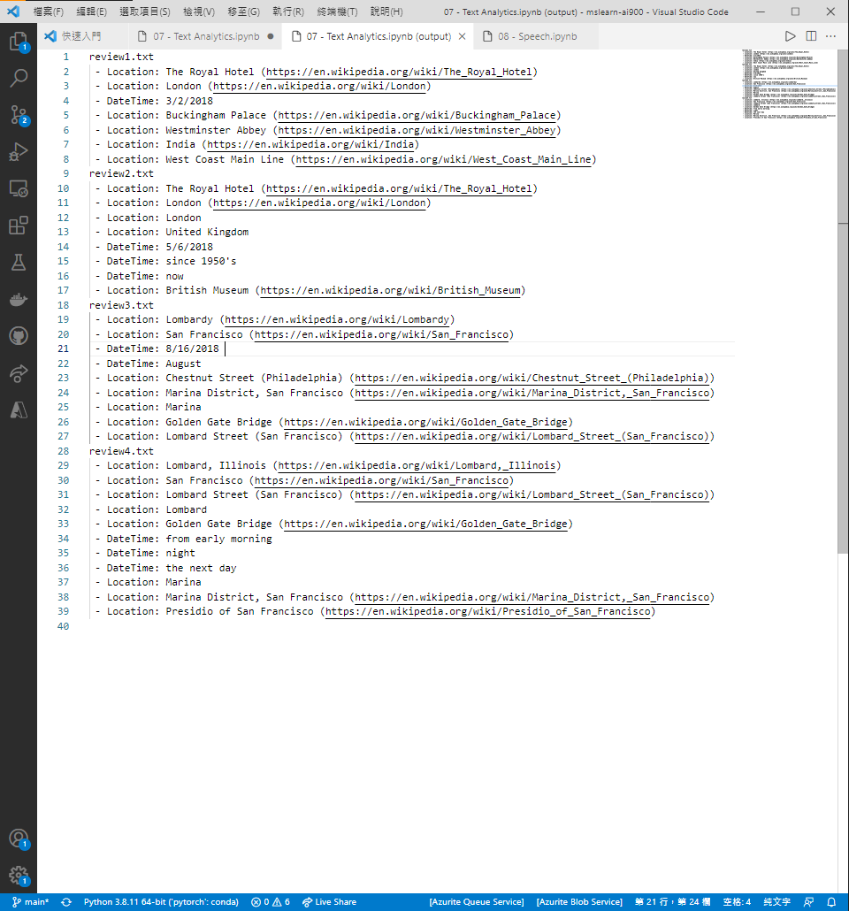

## Model 2: Recognize and synthesize speech

Part1: 英文網頁教程

* 1. Get the Key and Location for your Cognitive Services resource

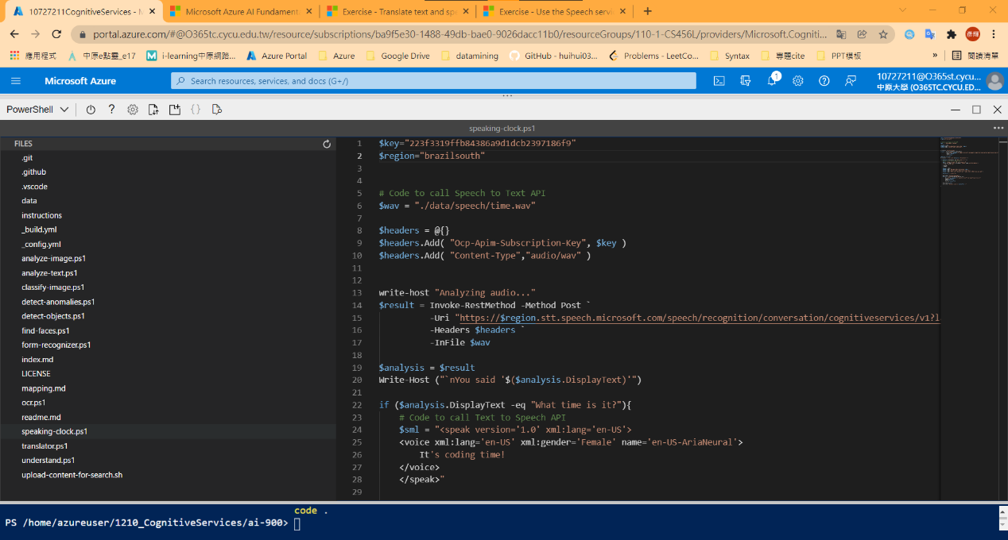

* 1. Speech recognition

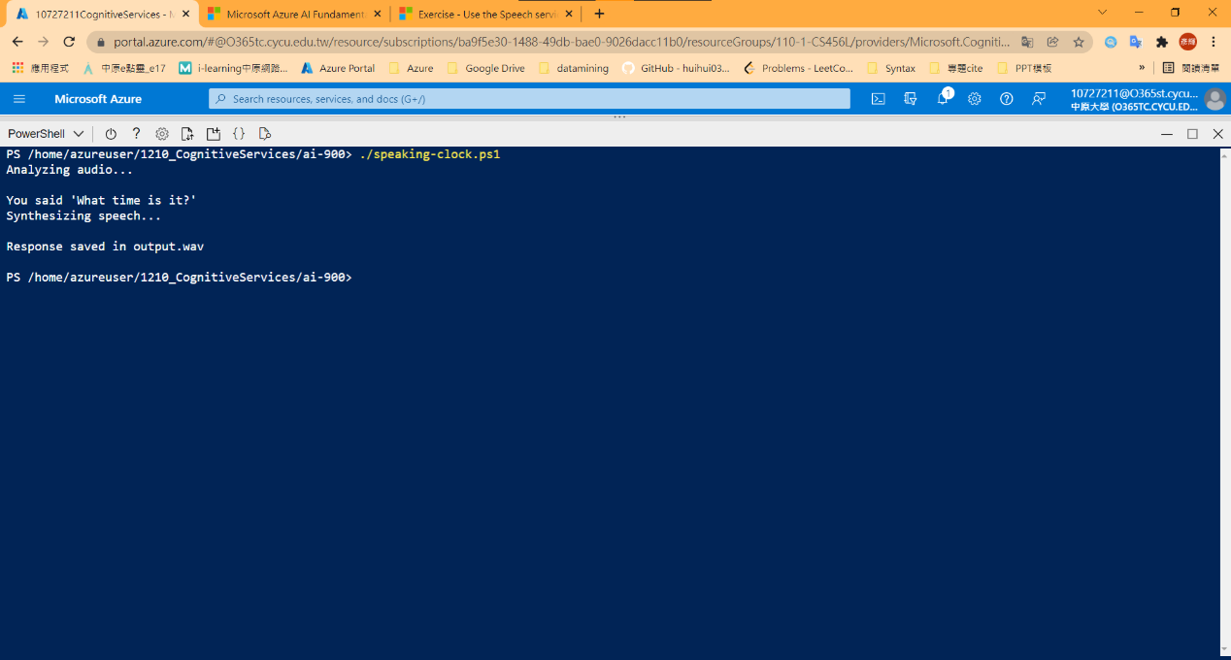

Part2: 中文網頁教程

* 1. Get the Key and Location for your Cognitive Services resource

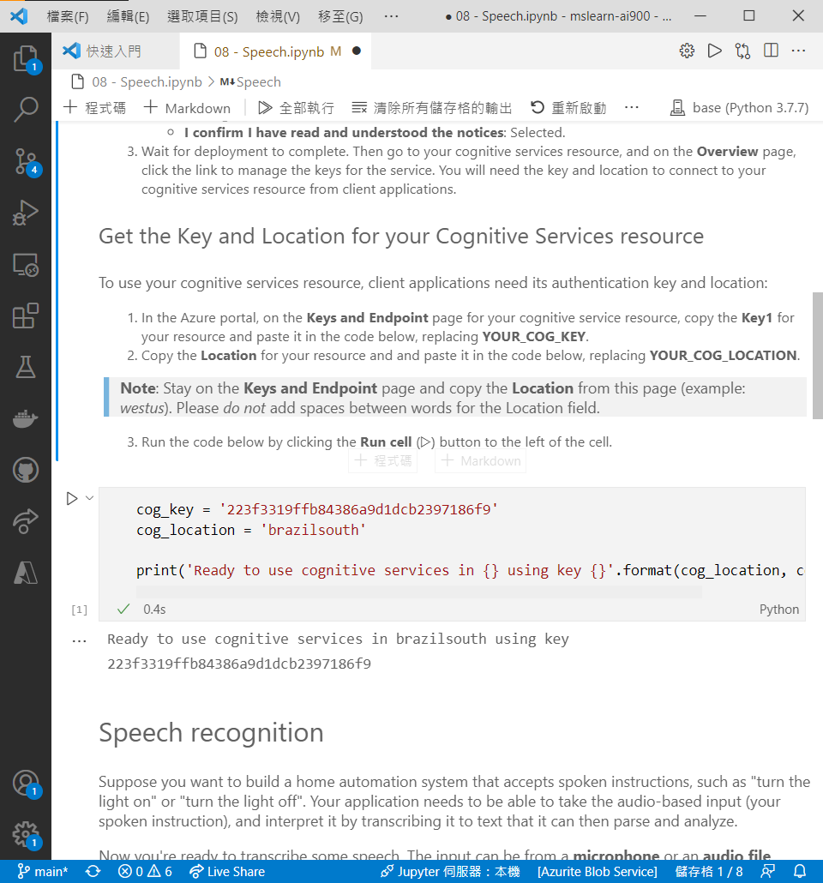

* 1. Speech Recognition

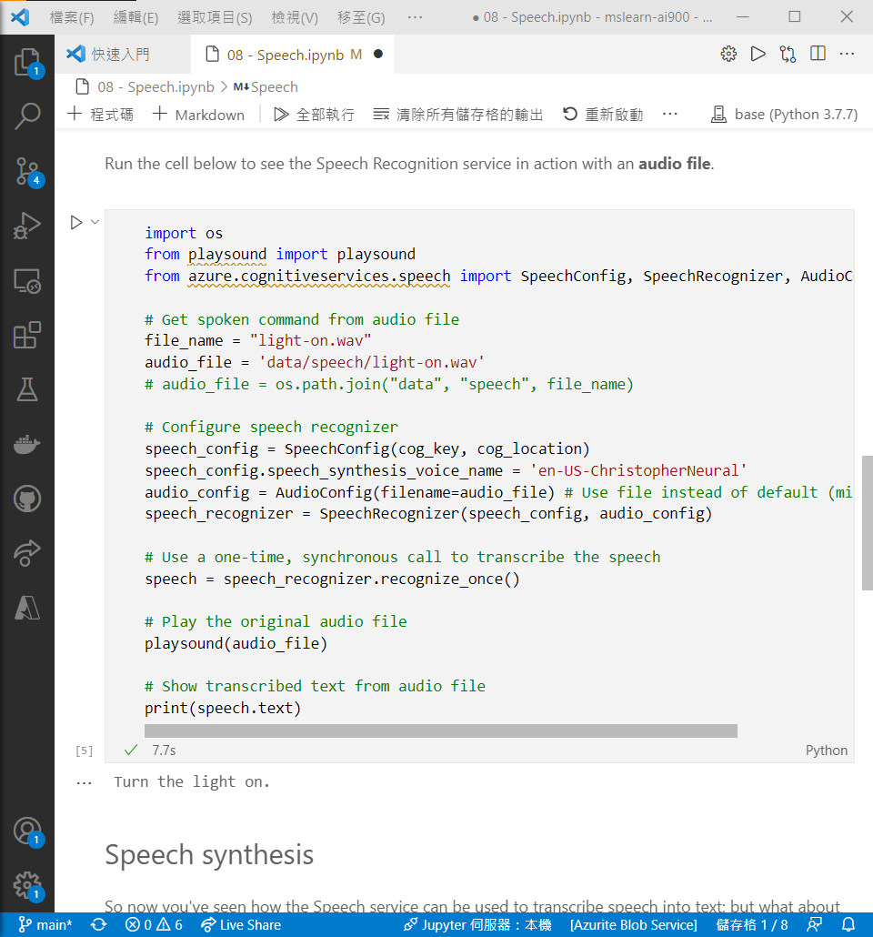

* 1. Speech synthesis

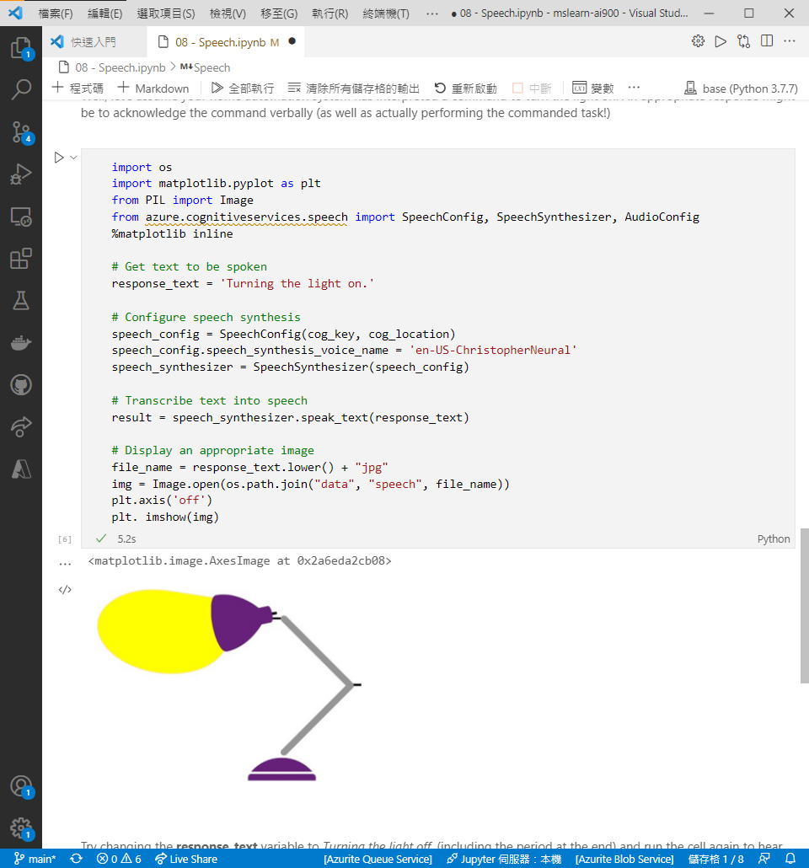

## Model 3: Translate text and speech

Part1: 英文網頁教程

* 1. Get the Key and Location for your Cognitive Services resource

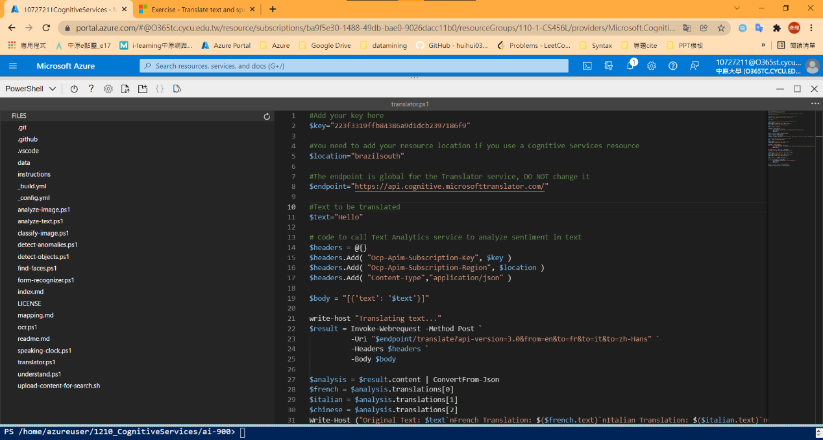

1-2. Speech Translation

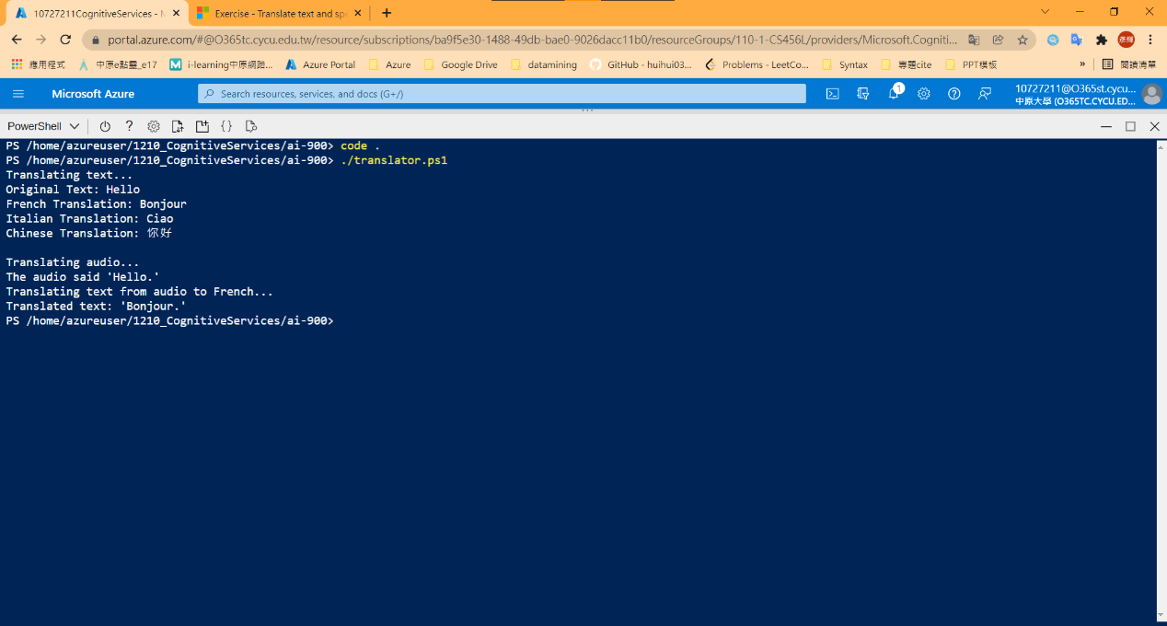

Part2: 中文網頁教程

* 1. Get the Key and Location for your Cognitive Services resource

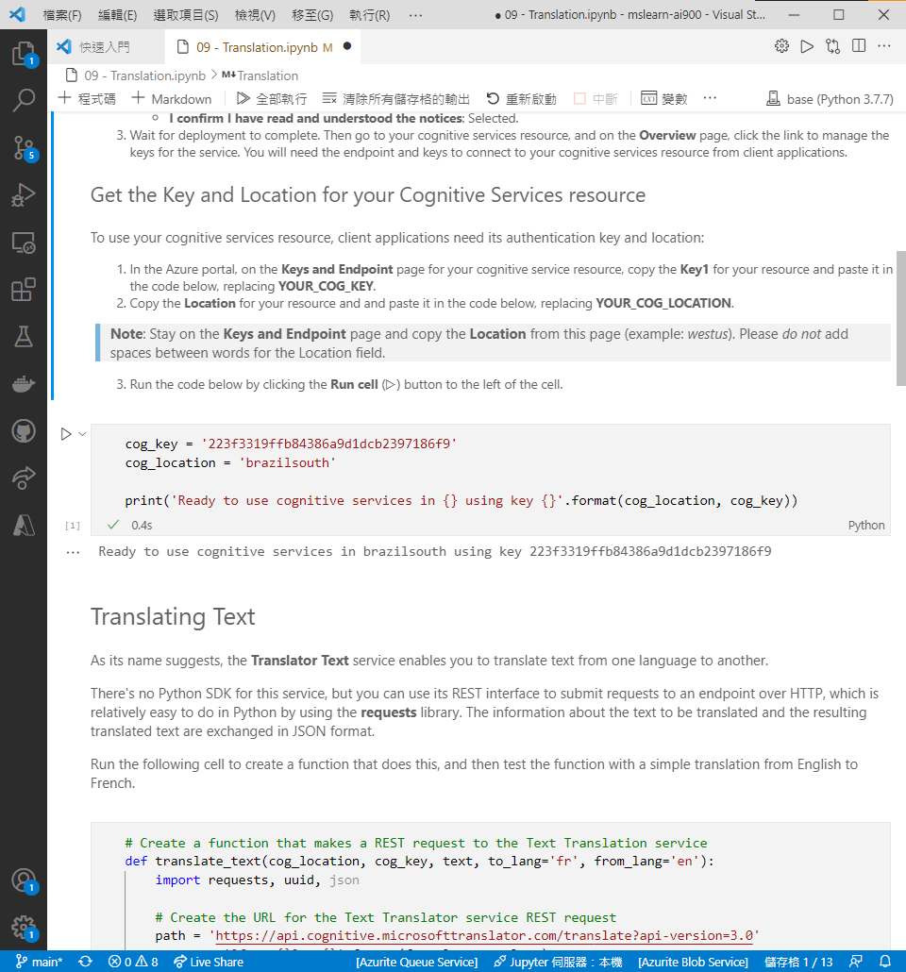

* 1. Translating Text

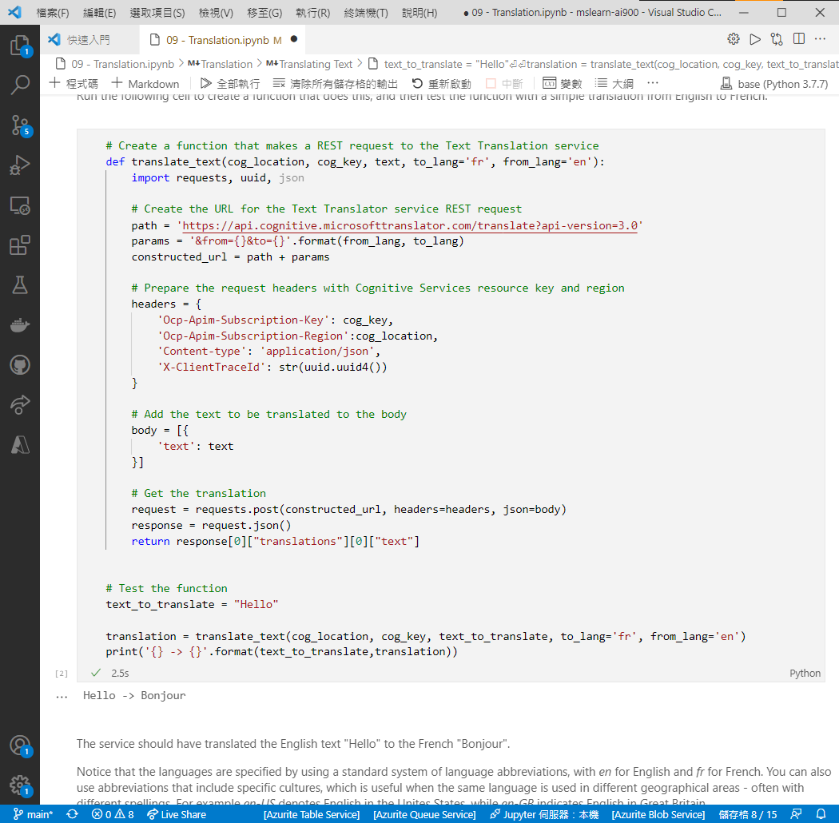

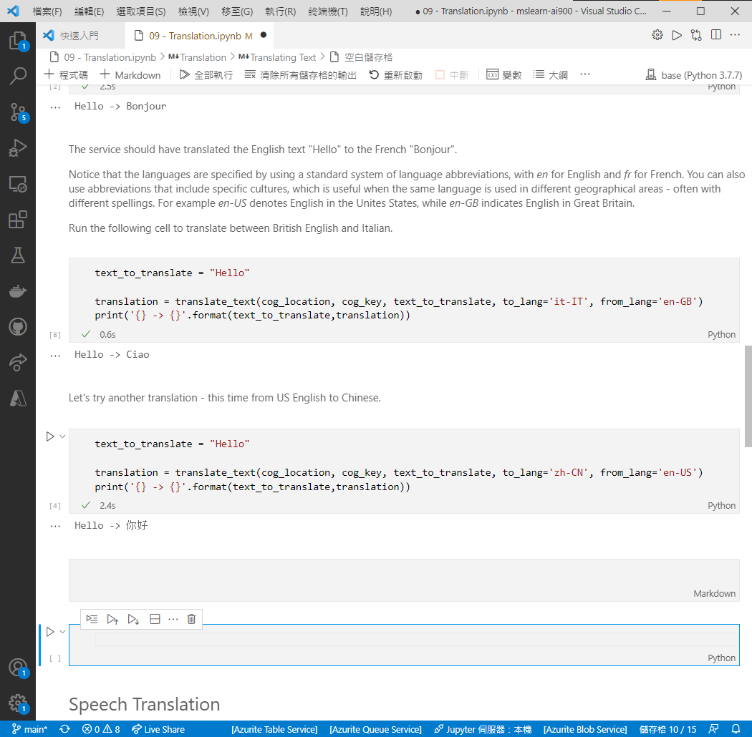



* 1. Speech Translation

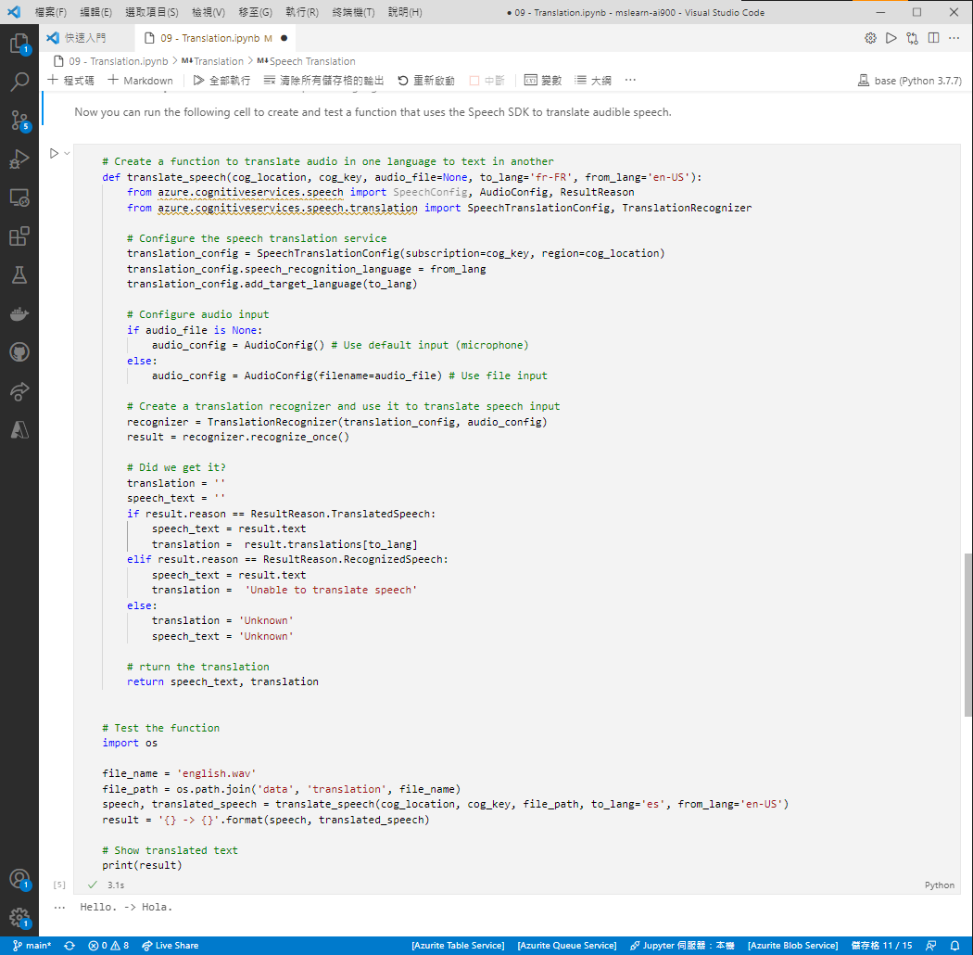

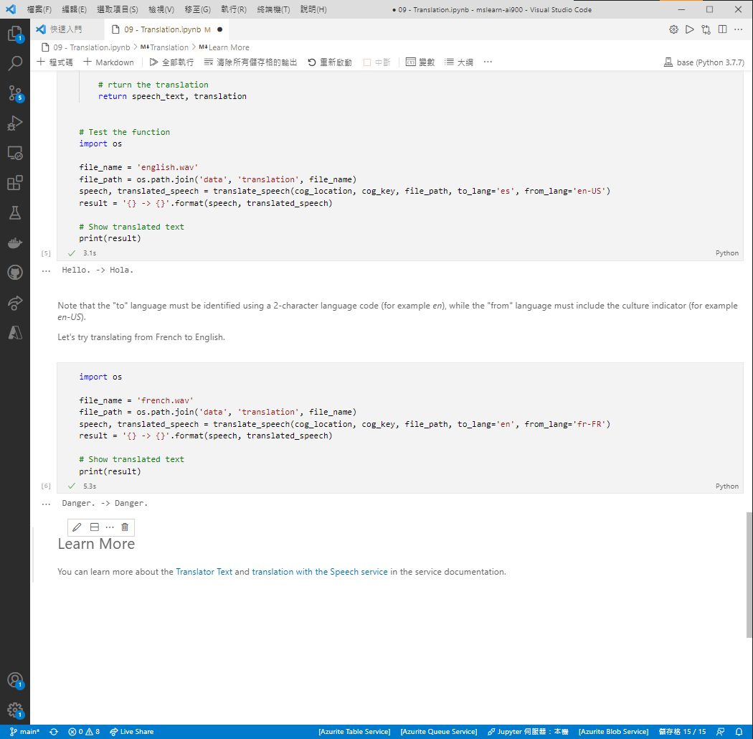

## Model 4: Create a language model with Conversational Language Understanding

1. Create a Conversational Language Understanding App

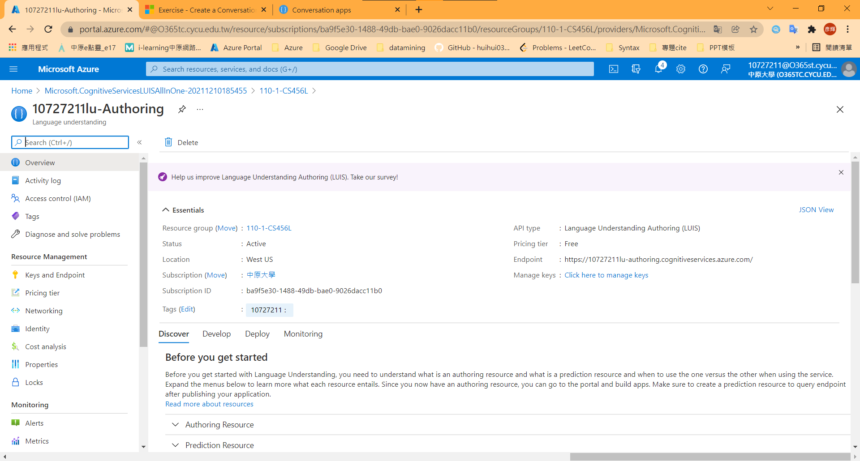

1. Create intents and entities

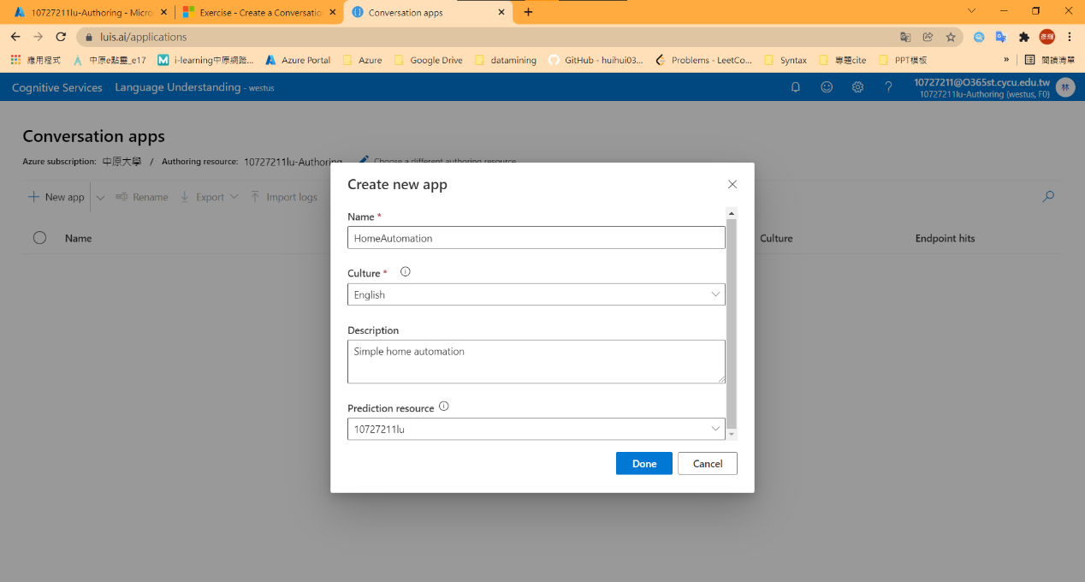

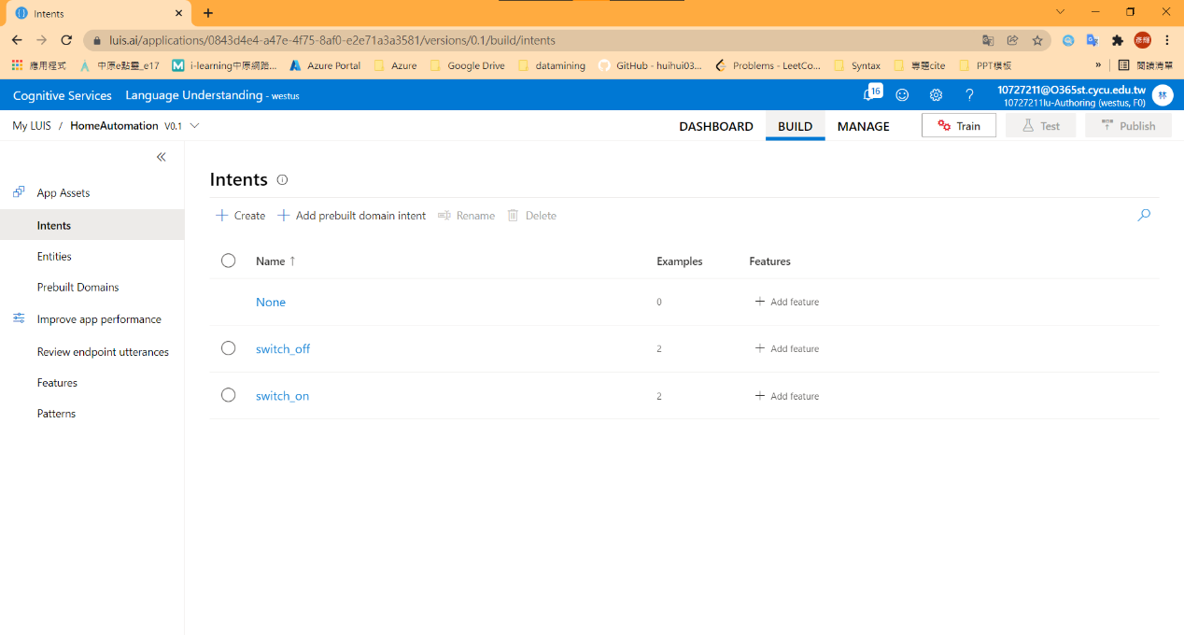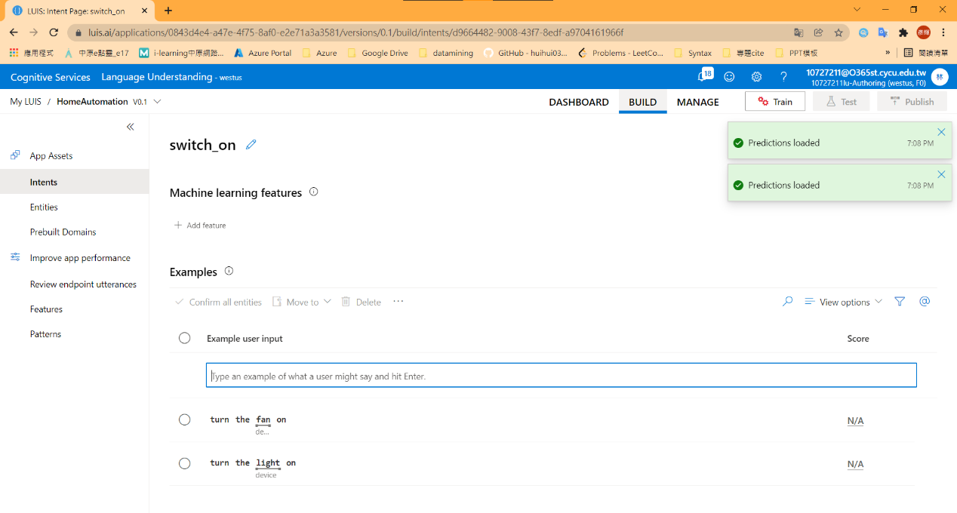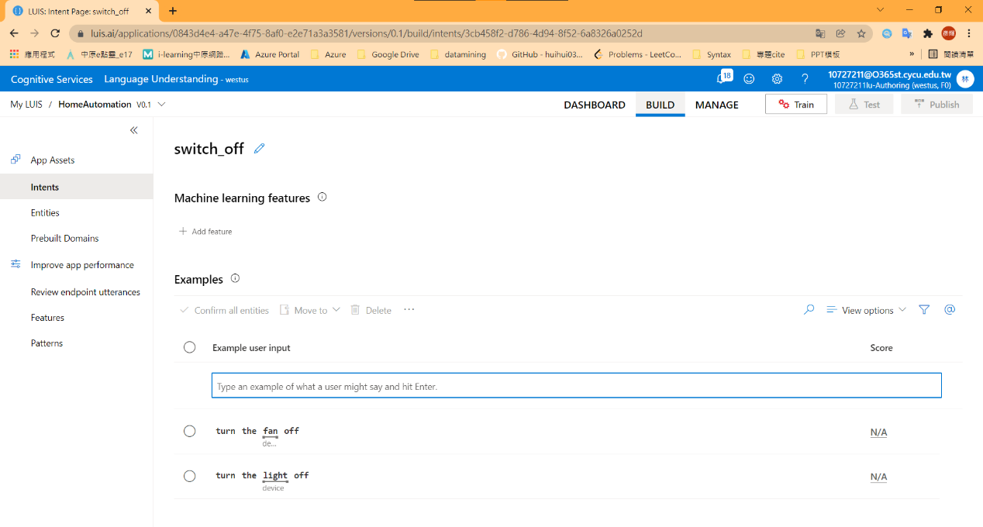

1. Train Language Model

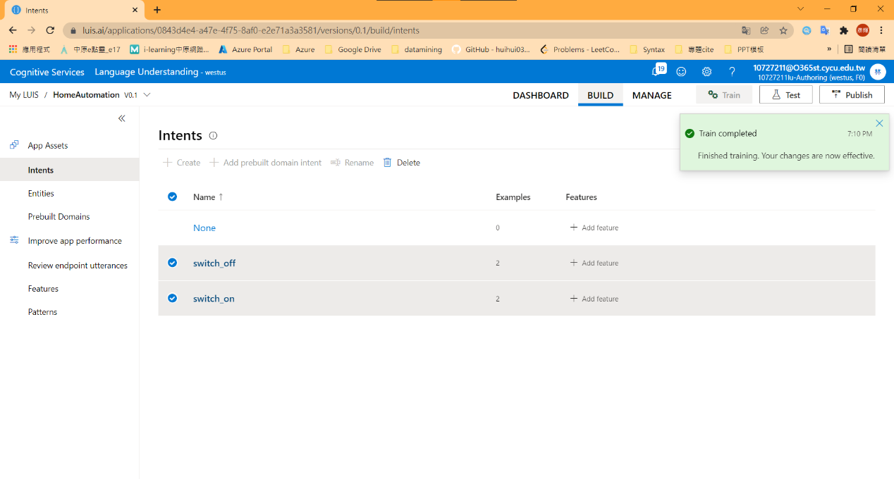

1. Test the Conversational

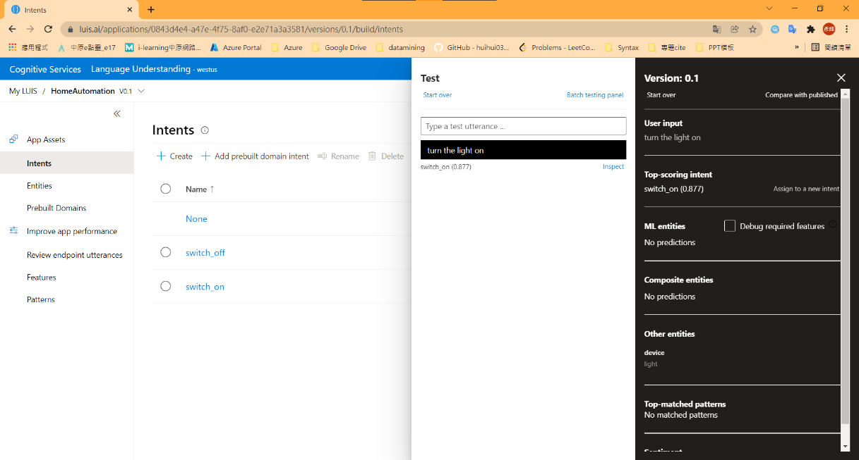 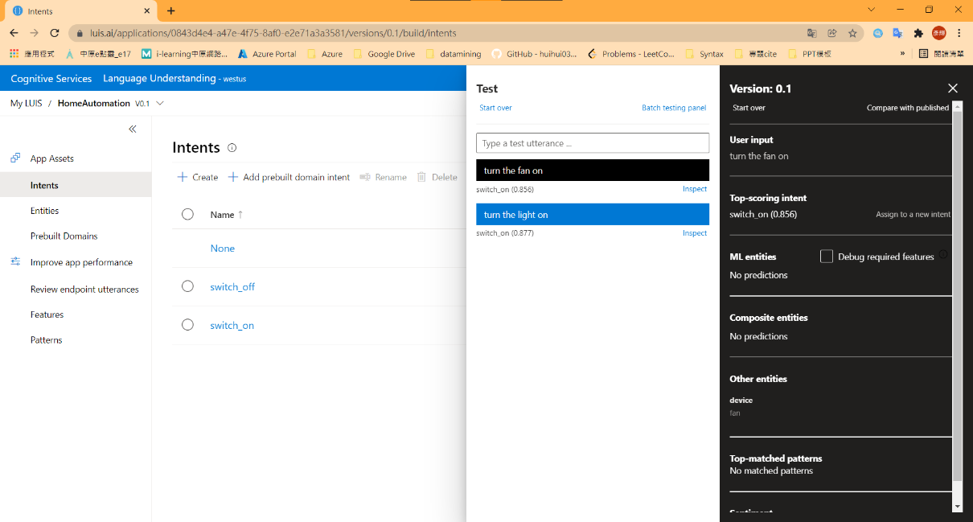

1. Publish

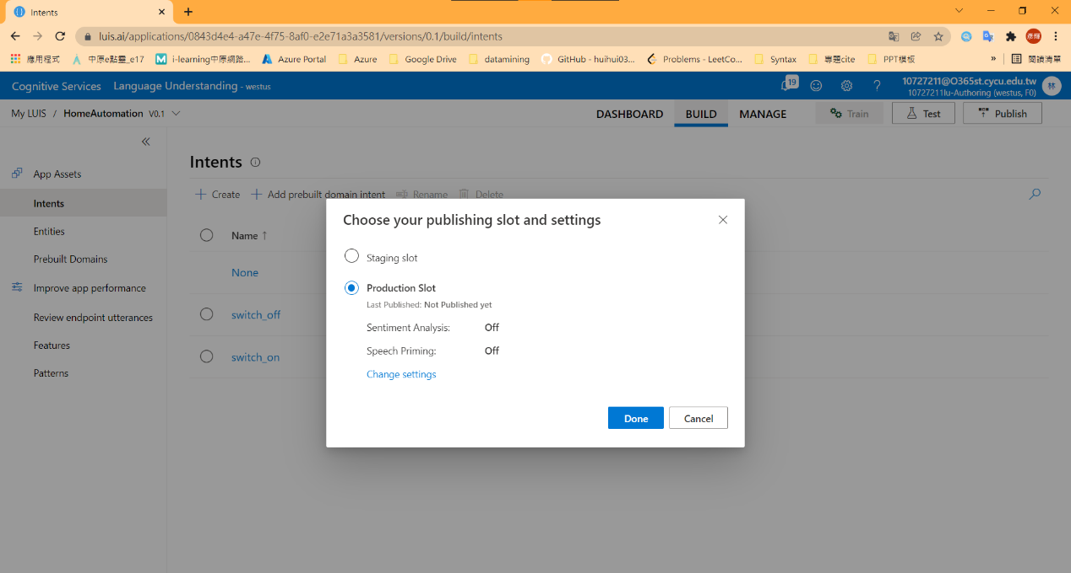

1. Command Input and show appropriate image

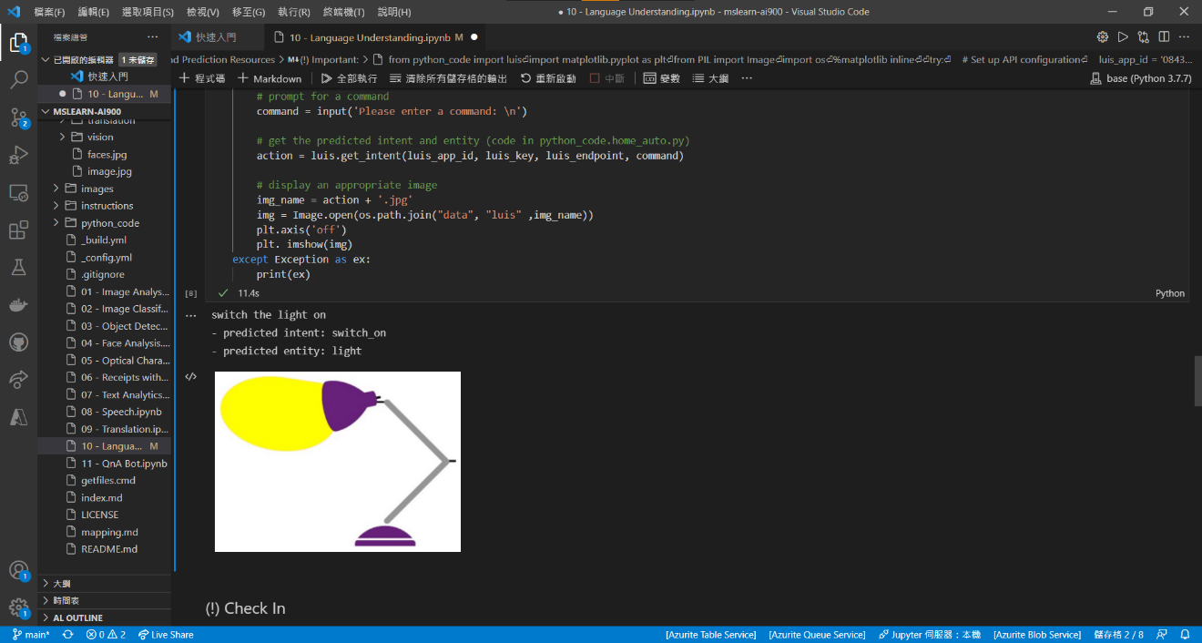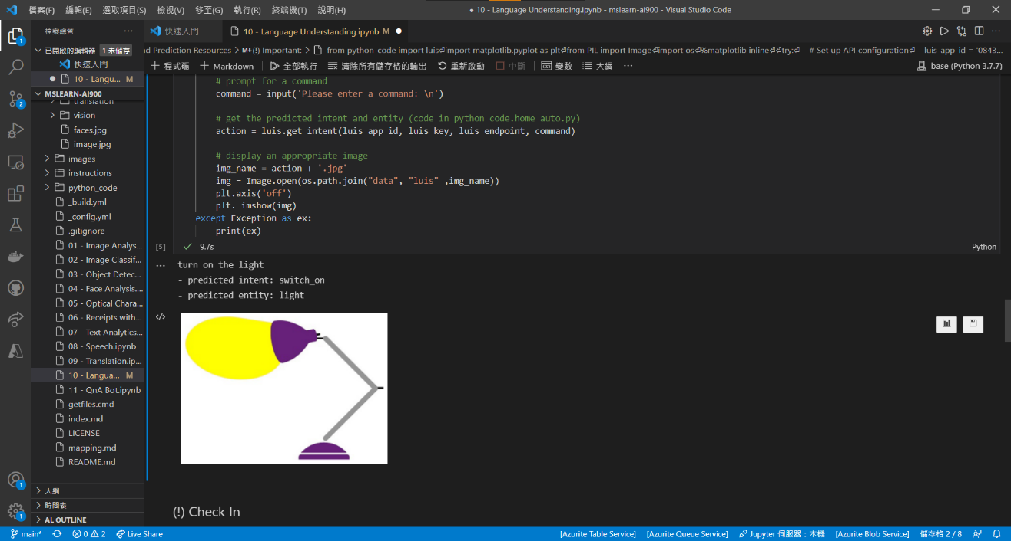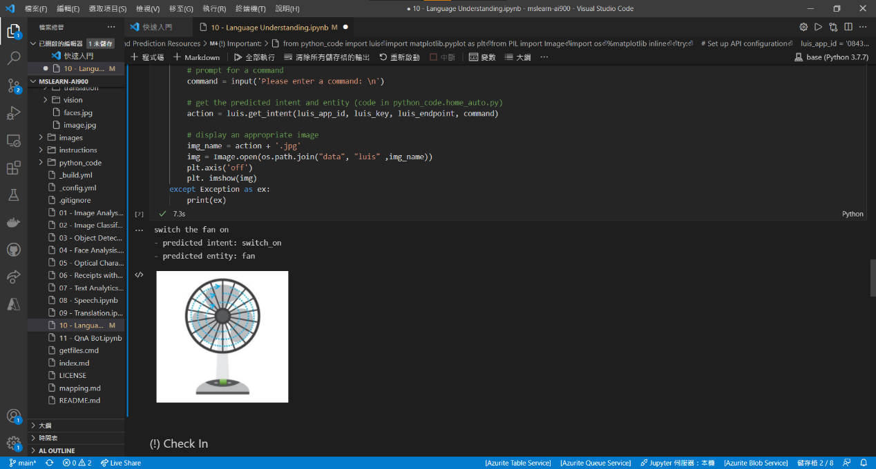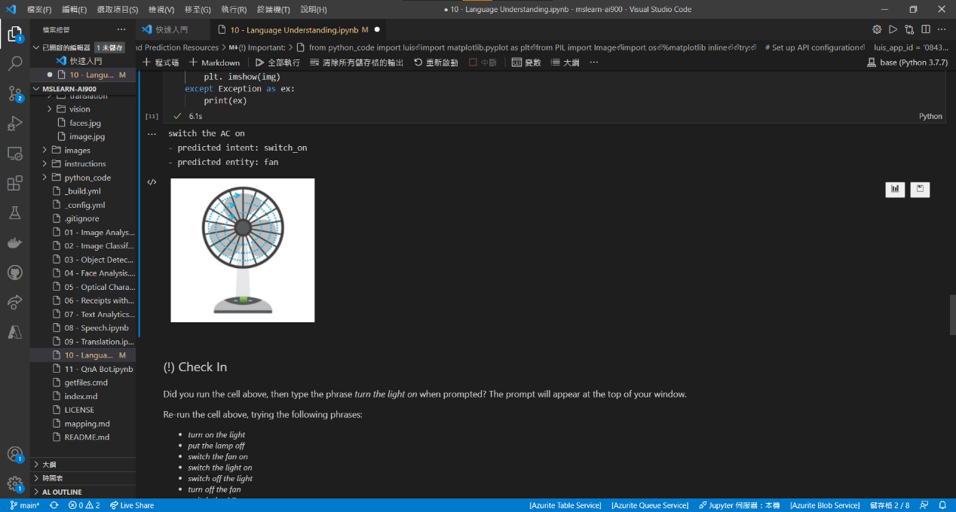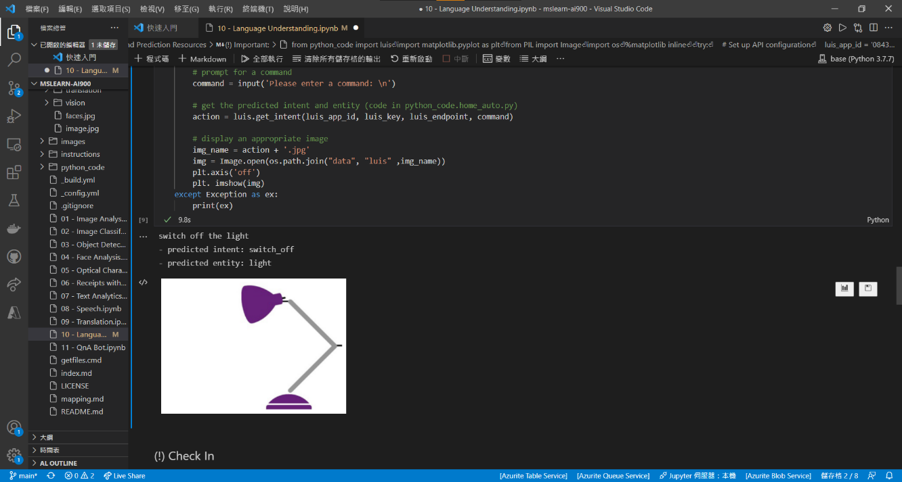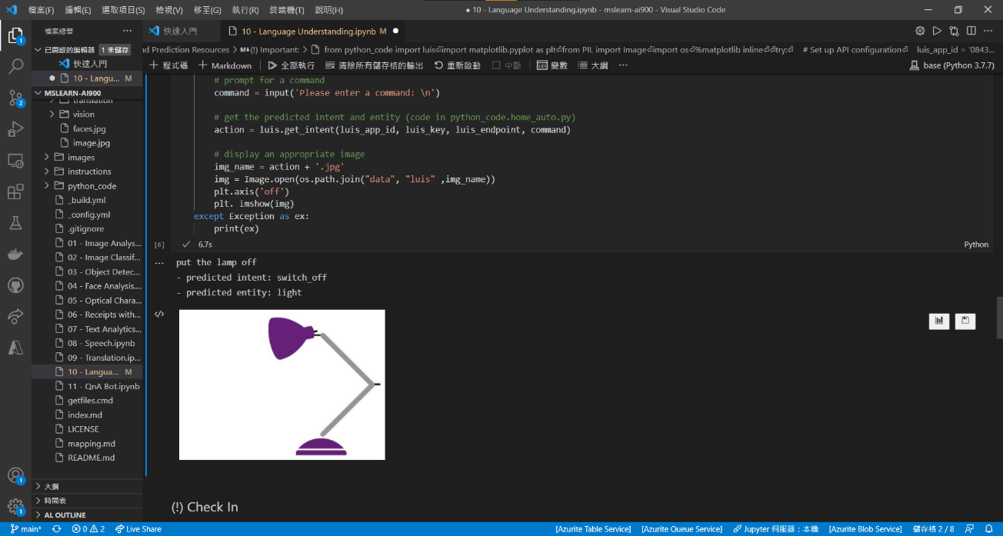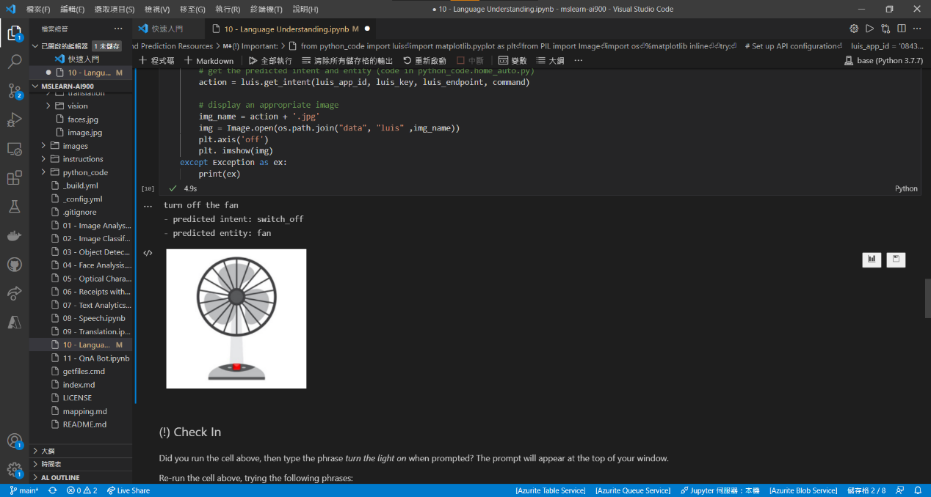

1. config Cognitive Service Resource

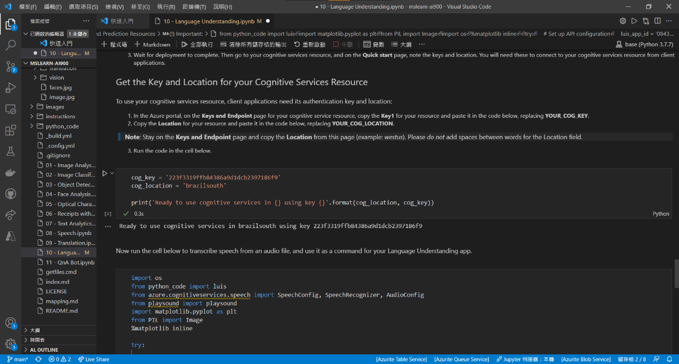

1. Speech Input and show appropriate image

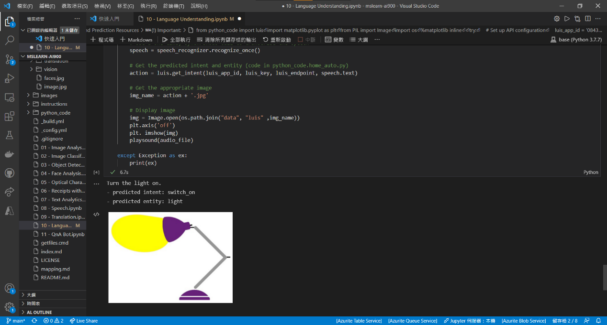

## Take screenshots of Badges and Trophies

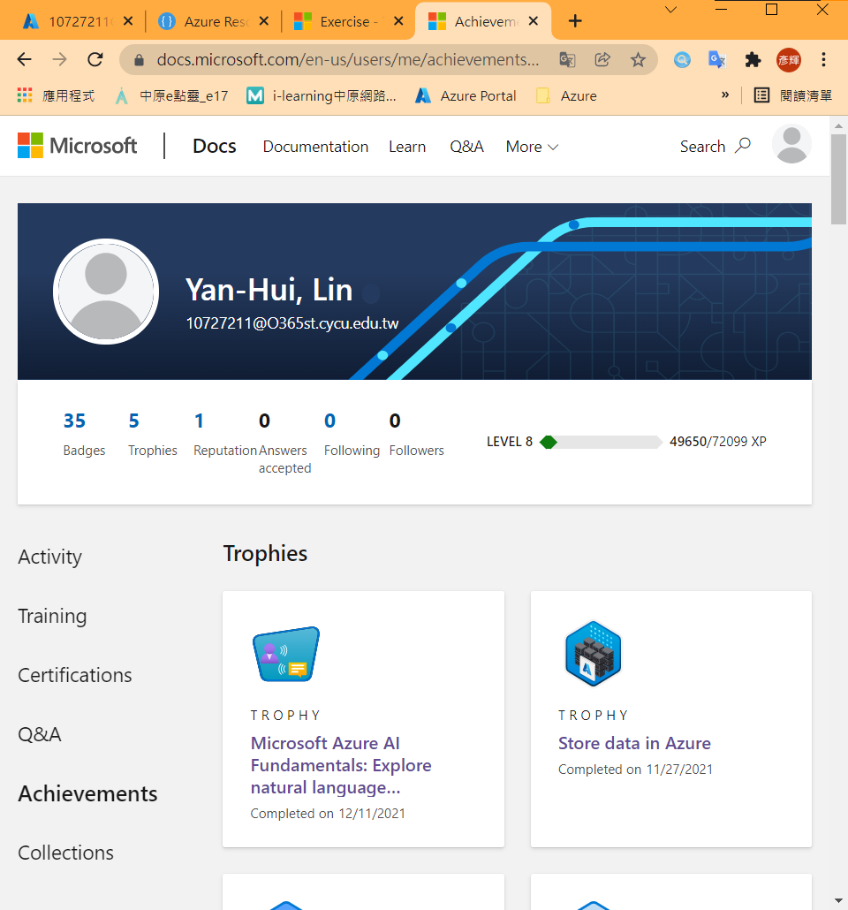

## Learned from the Learning Path

透過這次的Learning Path了解Azure在AI、自然語言的服務，從文本分析、語音分析、翻譯、語言理解都能透過Azure的API簡易達成，且API的功能簡單易懂，無須在開發時擔心過多有關自然語言的機器學習問題。Azure的Cognitive Services與Language Understanding能夠提供未來有關自然語言任務很大的協助。

# Problems

1. (英文版教程)

https://docs.microsoft.com/en-us/learn/modules/create-language-model-with-language-understanding/3-exercise-create-language-understanding-application

教程中缺乏home-devices.ps1，導致教程無法繼續完成。

1. (中文版教程)

實驗室無法開啟，解決方法為在本地環境下載Github範例程式碼並下載相關套件，安裝套件問題可直接至stackoverflow根據關鍵字找尋相關azure安裝指令。

1. DSVM

原先想透過DSVM的環境下載Github範例程式，但驗證卻遲遲無法通過，無法在110-1-CS456L的ResourceGroup中建立此資源。

# FeedBack

中英文版教程建議要統一內容，在這次學習的過程發現中英文的教程內容差異甚大，希望將來可以修正此類問題。